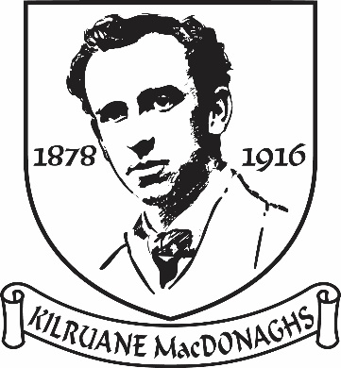

Tuairisc an Rúnaí
2022

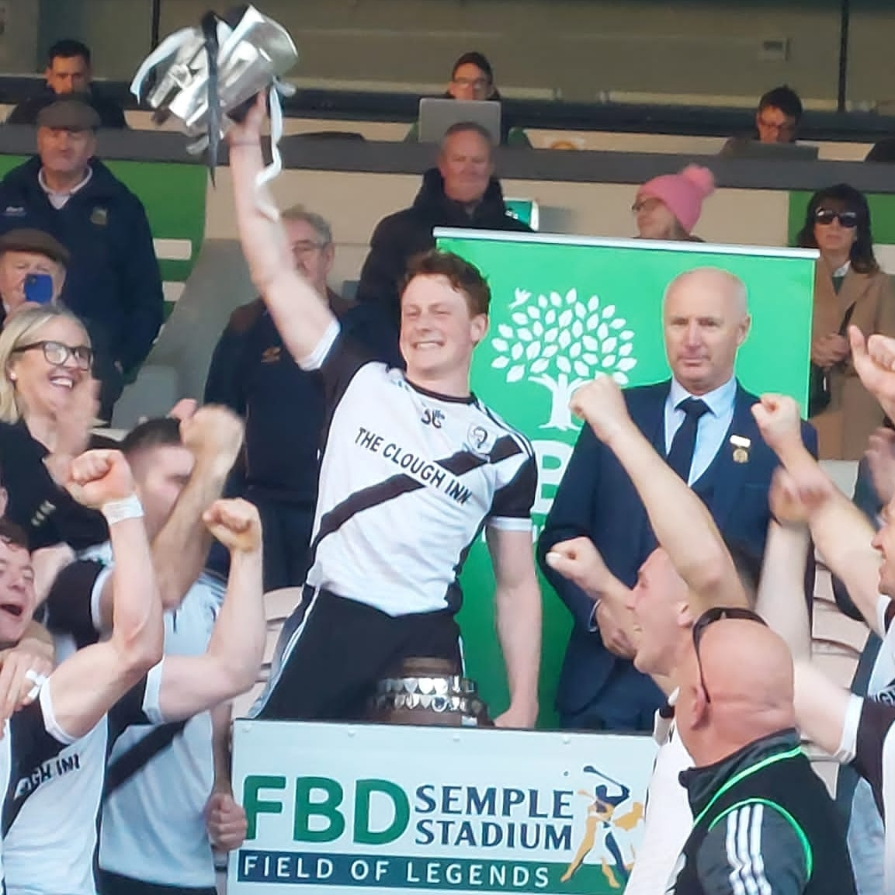

Club Officials 2022

Presidents: Len Gaynor, Fr. Pat Greed, Fr. Enda Burke, Carmel Daly
Vice-Presidents: Martin O’Meara RIP, Joe McCarthy, Des Gaynor, Jim Casey
Chairman: Joe Whelan
Vice-Chairman: Dave Carroll
Secretary: Martina Cleary
Assistant Secretary/PRO: Gilbert Williams
Treasurer: John Mulcahy
Registrar: Carmel Daly
Child Welfare Officer: Jenny Whelan
County Board & North Board Delegate: Gilbert Williams
Injury Claims Officer: Kay Cahalan
Health & Well Being Officer: Róisín Costello
School Liaison Officers: John O’Meara, Brian England & Gilbert Williams

Roll of Honour
All-Ireland Club 1
All-Ireland Sevens 1
Munster Club 1
County Titles 60
North Titles 164

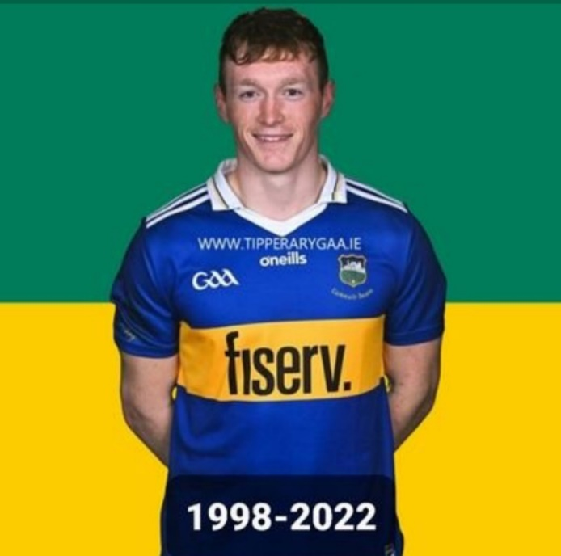
After emerging from the shadows of the Pandemic everybody looked forward to a year where some semblance of normality would prevail. However, comrade Putin wanted to play with his toys and sent his tanks across the border into Ukraine in a “Special Military Operation”. This invasion had serious implications for Ukraine but for countries around the world, particularly in Europe. It led to an energy crisis and worsened the cost of living crisis. Fortunately, the war had little impact on sport in Ireland. Full attendances were allowed at GAA matches as the split season proved to be an unqualified success despite journalists in the national media trying to undermine the concept for their own self-serving interests.
We will always remember 2022 as the year that the Dan Breen Cup returned to the parish after a thirty-seven year absence. The name of Dillon Quirke will be forever linked to this year’s competition. The way in which our players, management and the club in general dealt with the tragic events of Friday, 5th of August enhanced the reputation of Kilruane MacDonaghs throughout the county and nationally. After that fateful evening it seemed that the senior team was on a spiritual mission to honour Dillon in the best way possible by capturing the Dan Breen Cup.
The Junior ‘B’ footballers claimed the North title. I have no doubt that this stress-free competition helped bond the players into a more united group. On the Juvenile front our U13 hurlers created history by completing the North & County double in the ‘A’ and ‘D’ championships while the U17 footballers claimed the ‘B’ title for the first time. Their success was just reward for both the quality and quantity of coaching the players received. Cloughjordan and Ardcroney schools captured North football titles while Kilruane School U11 hurlers claimed the County title in Semple Stadium.
Not a bad year. The challenge for the club in 2023 is to build on this year’s success and ensure that we are competitive in all championships.
Senior
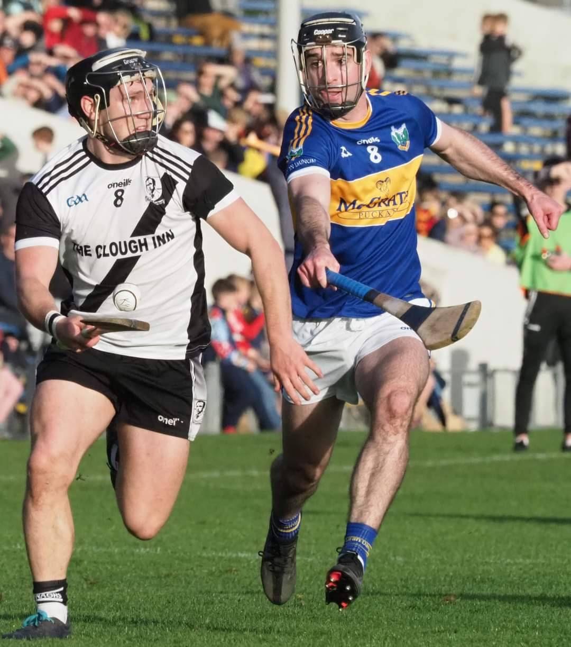
Deep into added time in the refixed second round group game against Clonoulty Rossmore in Templetuohy the sides were level. MacDonaghs needed victory to secure a place in the quarter-final. Anything less and a third place in No Man’s Land awaited them. Sean McAdams, who had been subdued for most of the match, won a ball on the right hand side, made some space for himself and bisected the posts. Clonoulty had one last chance for an equaliser but the sliotar drifted wide. The one-point victory saw MacDonaghs top the group and into the quarter-final as one of the top seeds. On reflection, this was the turning point of the year. From then on the team should gradual improvement until the County title came to Cloughjordan parish for the sixth time.
The team had a good league campaign and just missed out on qualification for the semi-finals. However, in the North quarter-final an extra time defeat to an understrength Kiladangan side gave little indication that MacDonaghs would be in the hunt for honours at the end of the season. At one stage Kiladangan were ten points ahead but Kilruane rallied to force extra time. However, our neighbours prevailed and our North campaign was over. The one chink of light from that defeat was that the team, despite struggling in many areas, had shown great heart to force added time.
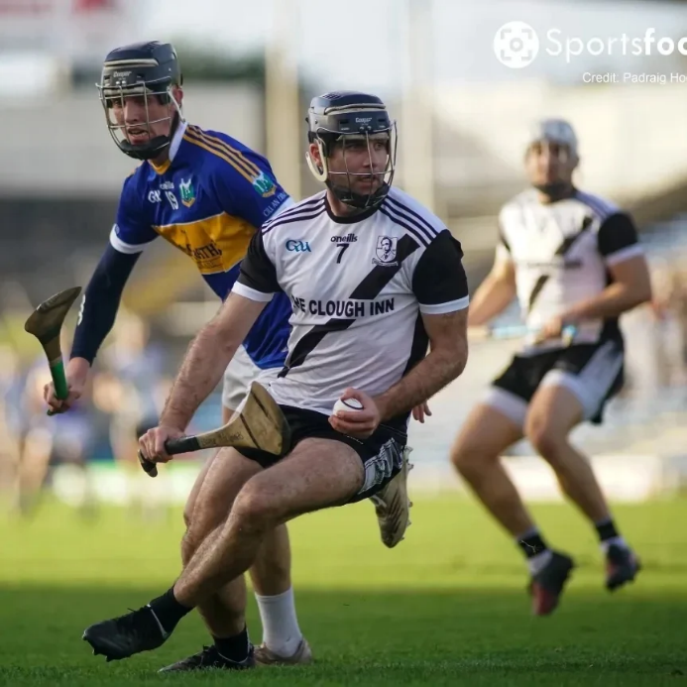
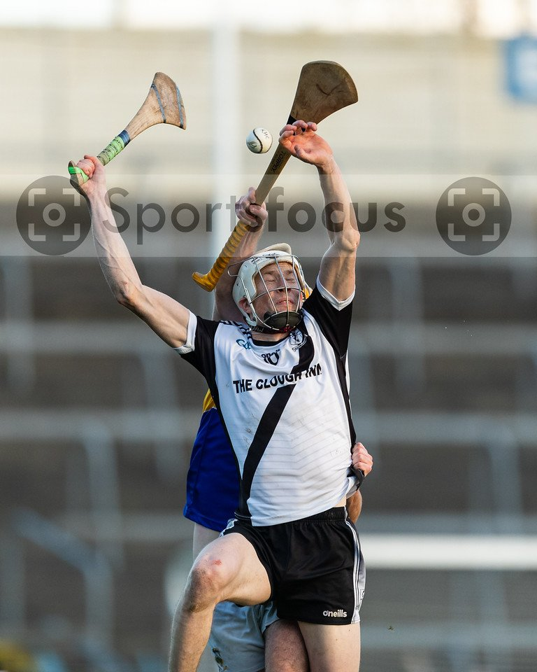
The County championship began with a victory over Moycarkey Borris. It was an evening that everything seemed to go right for the Magpies and little went right for the Mid men. They were forced to line out without their regular goalkeeper and lost one of their key forwards in the opening minutes. Moycarkey didn’t do themselves justice that evening and nobody in the MacDonaghs camp read too much into the margin of victory. Next up was Clonoulty Rossmore. Since Len Gaynor guided the West men to County honours in 1989 there has always been a very close bond between the clubs. On 5th August MacDonaghs faced Clonoulty in Semple Stadium. On that beautiful evening little did we think that the tragic events that were about to unfold would bring the clubs closer than ever. When Dillon Quirke fell ill with his friend Craig Morgan kneeling by his side the game was abandoned. We left the Stadium concerned for Dillon’s welfare but hoped he would make a full recovery. When news filtered through that night that Dillon had passed away people were numb with shock and a dark cloud descended over the parish. In the difficult days that followed the Kilruane MacDonaghs club stood shoulder to shoulder with the Quirke family and the Clonoulty Rossmore Club.
Hurling now seemed unimportant but paradoxically hurling became more important than ever. The management handled the situation sensitively and gradually the team returned to training. In memory of Dillon Quirke the players and management felt honour bound to give their best in every game. The order of games was rescheduled and MacDonaghs faced Nenagh in the Ragg. Very little separated the sides until a late flurry of scores gave Nenagh an eight-point victory. Craig Morgan limped off with a knee injury. Scans were later to reveal that he had suffered the dreaded cruciate injury. In the absence of Craig only an eternal optimist could see silverware at the end of the season. The result in the rescheduled Clonoulty game would now determine our fate. For obvious reasons it was going to be an emotional occasion. For sixty minutes friendships would have to be set aside and every ball would be vigorously contested. MacDonaghs shaded it with a point to spare and Clonoulty still remained in the hunt with their victory in the West final guaranteeing them a preliminary quarter-final spot.
Kilruane were drawn against the Toomevara in the quarter-final Semple Stadium. The Greyhounds, who had ruled the roost for many years, are always a difficult nut to crack and MacDonaghs were relieved to secure a two-point victory. Double chasing Upperchurch Drombane on the crest of a wave blocked Kilruane’s path to their first County final appearance since 1986. Inspired by captain Jerome Cahill, MacDonaghs booked their place in the final where we would renew acquaintances with our neighbours Kiladangan. There was a great build up to the final with the black and white colours flying proudly in all areas of the parish. However, Liam O’Kelly and his management team kept the players firmly focussed on the task in hand. Distractions were kept to the bare minimum as they prepared for a very formidable challenge against a talented Kiladangan outfit.
MacDonaghs were the better side the first day but after a pulsating final quarter were relieved to see the reliable Willie Cleary convert an injury-time free to earn a replay. At the mandatory post mortems that night old and wise heads whispered, “that we had left it behind us.” Their predictions seemed worryingly accurate in the replay when a much sharper Kiladangan team deservedly took a five-point lead into the dressing room at the interval. Only a fantastic save by keeper Páidí Williams from an early Barry Hogan penalty, the halftime situation could have been beyond redemption. However, MacDonaghs were a transformed team in the second half. They got the bit between their teeth and outscored Kiladangan 2-13 to 0-7 to claim the Dan Breen Cup for the first time since 1985 with seven points to spare.
At the final whistle blew crowds surged on to the hallowed sod to hail the heroes, among them grizzled veterans of the seventies and eighties who were delighted to pass on the baton. To witness the sheer joy on the face of Club President Len Gaynor and a host of other diehard hard supporters was something to behold. No less thrilling was to see the exuberance of the young boys and girls who will be inspired to emulate the heroes of 2022. Our parish exiles attended in droves, confirming the old adage that the savage loves his native shore. The Kilruane MacDonaghs Club is the heartbeat of our community so it was uplifting to see so many families who moved into the parish in recent years celebrate as if they were Magpies from the cradle.
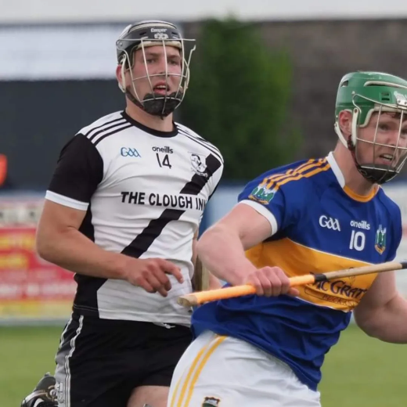
The club dedicated the victory to the memory of the late Dillon Quirke. One of the first men to congratulate manager Liam O’Kelly was Dan Quirke, father of Dillon. After the presentation the panel and management knelt in silent tribute near the spot where Dillon had fallen on that fateful evening. The village was bursting at the seams on Sunday evening as the team was welcomed home. Cloughjordan hadn’t witnessed such a gathering since the All-Ireland club homecoming in 1986.
Tremendous work done in the club over many years by many dedicated coaches with underage players and by successive senior management teams helped lay the foundations of this latest success. Great credit is due to manager Liam O’Kelly, coaches Christy Morgan and Brian O’Meara, selector Pat Murphy and the entire backroom team for welding the team into a spirited cohesive unit that overcame many obstacles and surmounted numerous hurdles to capture the Holy Grail.
It has been a difficult few years in the parish which has been touched by tragedy with many club stalwarts passing to their eternal reward. The presence of Dan Breen will help lift our spirits and brighten the dark days of winter. The thirty-seven year famine is over. The cost of living crisis and the energy crisis are now only minor irritations.

County League
Rd 1 Monday 21st March in Borrisoleigh
Kilruane MacDonaghs 6-19 JK Brackens 4-14

Rd 2 Saturday 2nd April in MacDonagh Park
Kilruane MacDonaghs 5-14 Nenagh 0-24

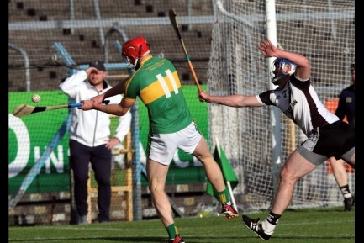
Rd 3 Friday 15th April in MacDonagh Park
Kilruane MacDonaghs 3-19 Thurles 1-23

Rd 4 Sunday 1st May in Clonoulty
Clonoulty 0-19 Kilruane MacDonaghs 0-17

Rd 5 Sunday 15th May in MacDonagh Park
Kilruane MacDonaghs 0-24 Borris-Ileigh 1-21

North Championship
Sunday 26th June Quarter-Final in Nenagh
Kiladangan 3-24 Kilruane MacDonaghs 4-16 (AET)

County Championship
Rd 1 Saturday 23rd June in Templederry
Kilruane MacDonaghs 4-22 Moycarkey 0-10

Rd 3 Sunday 21st August in The Ragg
Nenagh 3-19 Kilruane MacDonaghs 1-17

Rd 2 Sunday 4th September in Templetuohy
Kilruane MacDonaghs 3-15 Clonoulty 1-20

Quarter-Final Saturday 24th September in Semple Stadium
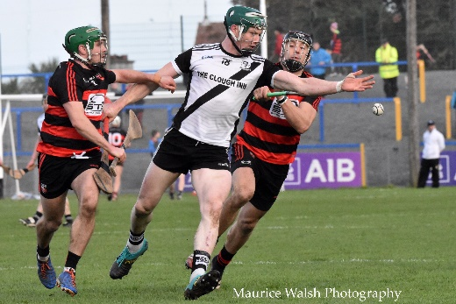
Kilruane MacDonaghs 2-17 Toomevara 2-15

Semi-Final Sunday 9th October in Semple Stadium
Kilruane MacDonaghs 2-17 Upperchurch 1-14

County Final Sunday 23rd October in Semple Stadium
Kilruane MacDonaghs 2-18 Kiladangan 1-21

County Final Replay Sunday 30th October in Semple Stadium
Kilruane MacDonaghs 2-20 Kiladangan 1-16

Munster Club Quarter-Final Sunday 6th November in Walsh Park
Ballygunner 4-19 Kilruane MacDonaghs 0-14

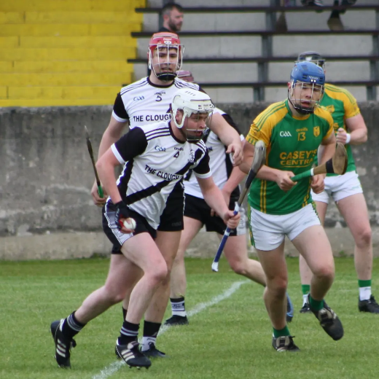
For the third year in a row we reached the semi-final. Our first round victory over Nenagh in the championship was the highlight of the season. It was this victory that secured a semi-final spot. The team also gave an impressive display in the second round, losing out to Toomevara by a point. The remainder of the championship and League followed a similar pattern to previous years. There was no lack of effort from players and management but the reality is that we haven’t the depth of talent as other teams in the ‘A’ championship. The occasional victory we manage to achieve gives a false illusion that all is well. A competitive Junior ‘A’ team is vital in providing a pathway for players to play senior hurling. There is no quick fix to change the fortunes of our Junior ‘A’ team. I suggest that the Juniors & Seniors train together and maybe the same management for Seniors & Juniors could be considered. It would lead to greater cohesion between both squads. Thanks to John Quinlan, Jim Williams, Colin England, Alan Quinlan, John Hyland and June Whelan (Physio) for their efforts with the team.
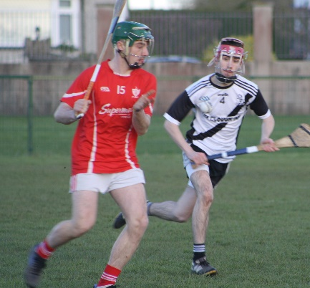
North League
Junior ‘A’
Rd 1 Conceded to Nenagh
Rd 2 Friday 8th April in Roscrea
Roscrea 1-19 Kilruane MacDonaghs 3-6

Rd 3 Friday 22nd April in MacDonagh Park
Borris-Ileigh 1-19 Kilruane MacDonaghs 1-15

Friday 29th April in Toomevara
Toomevara 6-26 Kilruane MacDonaghs 2-11

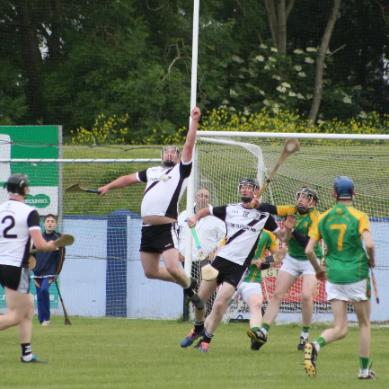
Rd 4 Friday 6th May in Puckane
Kiladangan 1-22 Kilruane MacDonaghs 1-10

Championship
Rd 1 Friday 3rd June in Toomevara
Kilruane MacDonaghs 1-16 Nenagh 1-15

Rd 2 Saturday 11th June in Nenagh
Toomevara 1-19 Kilruane MacDonaghs 1-18

Rd 3 Friday 15th June in Toomevara
Borris-Ileigh 3-17 Kilruane MacDonaghs 1-11

Semi-Final Friday 29th July in Toomevara
Borris-Ileigh 1-23 Kilruane MacDonaghs 2-12

Junior ‘C’

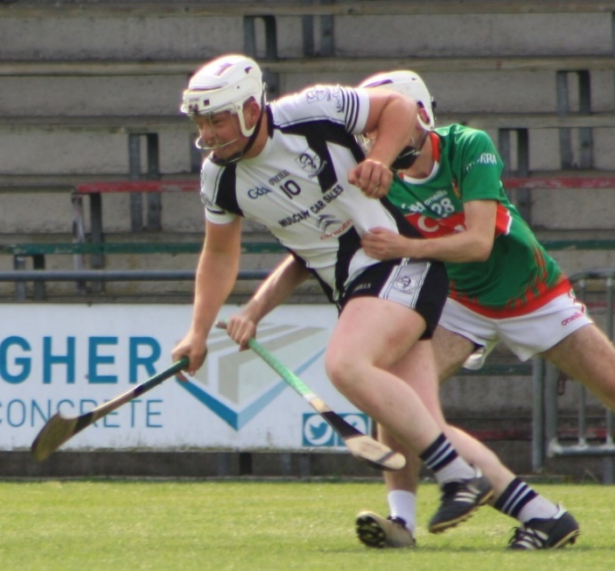
For the second year in a row we managed to field a team in this championship. Challenge games were played against Birr, Ballina and Silvermines. Manager Thomas Williams did Trojan work in mustering a quorum for the first two rounds where the team gave a very good account of themselves. Unfortunately, with injuries mounting we ran short of bodies and had no option but to concede the final game to Kiladangan. We were still in the hunt for a semi-final spot at this stage but despite the best efforts of Thomas Williams we couldn’t make the numbers. Injuries to Junior ‘A’ players deprived the Junior ‘C’ team of a number of players. This is a very important competition for us. It provides a pathway for the young player into adult hurling and also gives an opportunity for older players to hurl with the club. Thanks to Thomas Williams, Declan Barrett and Eoin Hogan for their work with this squad.

Championship
Rd 1 Friday 26th August in Roscrea
Kilruane MacDonaghs 3-13 Roscrea 0-13

Rd 2 Sunday 25th September in MacDonagh Park
Silvermines 1-14 Kilruane MacDonaghs 1-13

Under 19 ’B’ Hurling

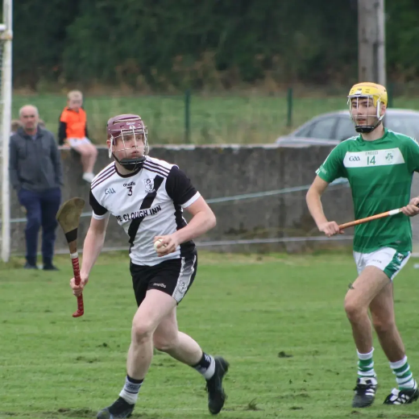
This competition is in its second year and has yet to be fully embraced by clubs and the Boards. We had difficulty in putting a management team in place. Chairman Joe Whelan contacted numerous individuals but to no avail. Eventually, like the Little Red Hen, he assumed the responsibility himself and persuaded Pat Murphy, Fr. Pat Greed and myself to come on board. There were nine teams in the ‘B’ championship. We had advocated two groups but got little support in the boardroom. There were three groups of three which was knockout in all but name.
We began with an encouraging home draw against championship favourites and eventual champions Borris-Ileigh. A victory over a depleted Borrisokane side earned a quarter-final slot. The team gave their best display of the season in the home quarter-final victory over Newport. In the semi-final Moneygall/Clonakenny proved too good. During the year the team trained with the U17s and this ensured that there were good numbers in attendance. Jack Peters did the bulk of the training with Christy Morgan, Jerome Cahill and Craig Morgan also doing sessions. The U19s were an easy group to train and they showed definite improvement during the year.

League
Wednesday 20th April in Templederry
Kilruane MacDonaghs 0-19 Templederry/Ballinahinch 1-10

Wednesday 27th April in MacDonagh Park
Kilruane MacDonaghs 3-18 Portroe 2-10

Championship
Rd 1 Wednesday 6th July in MacDonagh Park
Kilruane MacDonaghs 2-12 Borris-Ileigh 0-18

Rd 2 Wednesday 27th July in Borrisokane
Kilruane MacDonaghs 3-22 Borrisokane 0-5

Quarter-Final Wednesday 10th August in MacDonagh Park
Kilruane MacDonaghs 2-13 Newport 1-14

Semi-Final Wednesday 17th August in Borrisoleigh
Moneygall/Clonakenny 2-16 Kilruane MacDonaghs 2-11

Football
Rd 1 Wednesday 6th April in MacDonagh Park
Moneygall/Clonakenny 0-8 Kilruane MacDonaghs 1-4

Junior ‘B’ Football

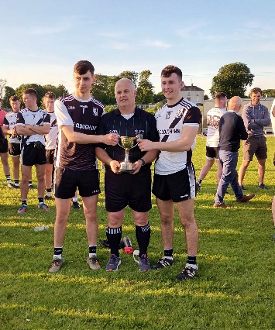
In the past football silverware has often been the catalyst for hurling success and so history repeated itself in 2022. With the divisional football championship played before the start of the hurling championship it meant that the management had a full deck from which to select a team. The fact that the same management was over both the senior hurling and junior football teams ensured that there was no friction over availability of players. There is no doubt that the success in this championship helped forge a strong team spirit which helped the senior hurling team prevail in the County final. The victory over Shannon Rovers in the North was our first success in junior football since 1975.

Wednesday 18th May in Ballina
Kilruane MacDonaghs 6-7 Ballina 4-7 AET

Semi-Final Thursday 26th May in Moneygall
Kilruane MacDonaghs 3-12 Moneygall 1-4

North Final Wednesday 1st June in Borrisokane
Kilruane MacDonaghs 5-8 Shannon Rovers 0-8

County Quarter-Final Saturday 15th October in Templetuohy
Kilruane MacDonaghs 3-8 Mullinahone 0-5

County Semi-Final Sunday 27th November in Newport
Kilruane MacDonaghs 2-5 Cappawhite 0-10

Under 21 ‘B’ Hurling

We were drawn in a group of three with Lorrha/Rovers and Silvermines. This year there is only as divisional championship. Following a motion passed at the November County Board Meeting there will be a County championship in 2023. At the time of writing this report we have just played the first round. chiselling out a draw with Lorrha/Rovers in Lorrha. Result: Kilruane MacDonaghs 3-13 Lorrha/Rovers 1-19.

Billy Boyle (1932-2022)
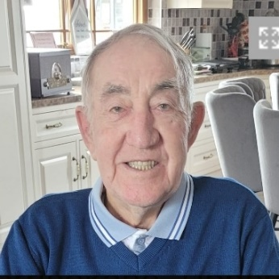
Billy first came to prominence when he played on the minor team that lost the 1949 North final to St. Mary’s Nenagh. Billy won his first medal with Kilruane MacDonaghs in 1954 when he lined out as goalkeeper on the side that overcame Kilcommon in the North junior final in Nenagh. Two years later Billy picked up his second North junior medal when MacDonaghs had a narrow one-point victory over neighbours Toomevara. In 1959 Billy was part of the senior panel that defeated Toomevara in the North Final. The following year Billy collected his third North junior medal when MacDonaghs got the better of Ballinahinch in the final. He added a County medal with the victory over Moycarkey in the decider.
In 1962 Billy played corner-back on the Tipperary intermediate team that lost to Cork in the first round of the Munster championship. The same year he was on the Kilruane intermediate team that lost to Moneygall in the North final. In 1963 Billy was once more part of the Tipperary intermediate team that won the Munster Final with a victory over Clare and captured All-Ireland honours by overcoming London in Thurles.
On the club front Billy progressed on to the senior team. In 1963 he was goalkeeper on the side that lost the replayed semi-final to Toomevara. There was no joy for Billy the following year with a defeat by Roscrea in the second round ending championship aspirations and 1964 yielded no success either. In 1965 he collected his second North senior medal when Kilruane pipped Lorrha in the final. The following year Lorrha turned the tables in the North semi-final. That particular game was to be Billy’s last in the Kilruane MacDonaghs colours.
He had won an All-Ireland, a Munster, a County and five North medals. Billy was a versatile performer playing in goals, in the backs, in midfield and in the forwards. He was the quintessential team player. Billy played where he was asked to play. The team came first. Many online tributes have referred to Billy as a gentleman and he was the same on the field.
As a mark of respect the Tricolour in MacDonagh Park flew at half-mast. Club members formed a Guard of Honour at his funeral and his coffin was draped in the MacDonaghs colours. Sympathy to Liam, John, Mary, Noeleen, Margaret & extended families. Go soilsí solas na bhFlaitheas air.

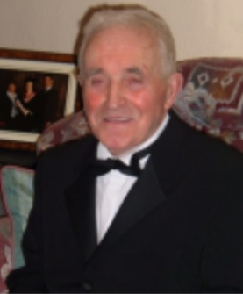
Dinny Heenan (1933-2022)
Dinny Heenan played juvenile and minor hurling with Kilruane MacDonaghs. He was full-forward on the 1949 minor team that lost to a very strong St. Mary’s Nenagh side in the North final. Also on the team was his great friend Noel Mulcahy. Both Dinny and Noel were instrumental in establishing the Ardcroney Drama Group. Over the years Dinny built a reputation as a very fine actor with an amazing stage presence. In 1980 Dinny teamed up with Noel Mulcahy, Anne Heffernan, Paddy Heffernan and Margaret O’Brien to win the Novelty Act competition in the North Scór final. Dinny had a great interest in greyhounds and was a familiar presence at the tracks around the country where he enjoyed some success. As a mark of respect the Tricolour in MacDonagh Park flew at half-mast. His coffin was draped in the club colours and both the Ardcroney Drama Group and Kilruane MacDonaghs members formed a Guard of Honour at his funeral. Ar dheis Dé go raibh a anam.

John Hyland (1966-2022)
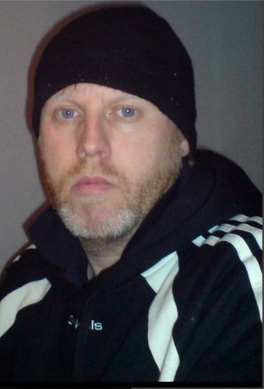
The late John Hyland was a member of the 1978 U12 hurling team that won our first divisional title in this grade. He was also a member 1980 U14 team, the most successful juvenile side that ever left the parish, which won North & County Rural and Urban Rural titles and reached the All-Ireland Féile Final in Galway. John’s next success was in 2004 when he won North & County Junior ‘B’ medals and a North Junior ‘B’ League medal. That was also the first year he became involved as a selector when he was with the U12 team. John was to go on and work with the Senior, Junior, U21, U19 and U16 teams. Some years he was involved with more than one team and he also found time to serve as a trainer and selector with the Junior ‘A’ camogie side that won the County League title in 2012. He also coached the Nenagh Ormond Senior Ladies Rugby team in 2014.
John became a selector with the senior hurlers in 2009 when they won the O Riain Cup. He filled the same role the following year and in 2019. He will be forever associated with the successful U21 teams. John was a selector on the sides that won the 2009 and 2010 North finals with the 2010 team going on to record a famous County final victory over Thurles Sarsfields in Dolla. In 2012 and 2013 he assumed the manager’s role with the U21s as they recorded successive divisional victories. Unfortunately, the 2013 team lost out by a point to Thurles in the County final. However, he did achieve County success that year when he was a selector with the U16 team that won a historic first County title in this competition. John also served on the club committee for a number of years. John was a passionate Kilruane MacDonaghs man to the core, a great clubman.
At his funeral his coffin was draped in the MacDonaghs colours and club members formed a Guard of Honour. The Tricolour in MacDonagh Park flew at half-mast as a mark of respect and a minute’s silence was observed before the U17 football final and the U21 hurling game against Lorrha/Rovers. Sympathy to his mother Helen, sisters Fiona & Deirdre, his brother Paul, the Hyland and Hayes families. Ar dheis Dé go raibh a anam.

Martin O’Meara (1928-2022)
Martin O’Meara, Kyle passed to his eternal reward on 30th May. Martin was a staunch supporter of MacDonaghs and the personification of club loyalty. He was no fair weather follower. Martin was there to back the Magpies through thick and thin, in sunshine or in rain and in venues near and far. He was present on the glory days in Semple Stadium but he was also there in less glamorous venues the length and breadth of the county when MacDonaghs were in action. Martin’s allegiance was never in question. For him it was Kilruane MacDonaghs and Tipperary. Martin followed the fortunes and indeed the misfortunes of Kilruane MacDonaghs and Tipperary. He revelled in their success and took the disappointments to heart. In his early years Martin and his family travelled on bicycles to support MacDonaghs. They also followed Tipperary at every opportunity.
The seventies and eighties were a golden period for Kilruane MacDonaghs. Martin would cycle in from Kyle to watch MacDonaghs training. It gave Martin great satisfaction that his nephew Johnny was on the successful three-in-a-row team in the seventies and that his brother Billy was a selector with that side. Hip surgery prevented Martin from attending the All-Ireland Club Final in Croke Park in 1986 but wild horses wouldn’t stop him from attending the celebrations in Cloughjordan that night.
In 2005 Martin was elected Vice-President and held the position for eighteen successive years. In 2019 the Tipperary County Board presented him with a Laochra Gael Award. Martin joined an elite group from the club who have been honoured with this accolade. As Martin’s mobility decreased in recent years he refused to let this handicap prevent him from attending club matches. Liam Haverty, his trusty chauffeur, brought him to the matches and managed to secure a good vantage point for viewing at most venues. Martin was present in MacDonagh Park, Nenagh in 2018 when he witnessed Kilruane MacDonaghs bridge a twenty-eight year gap to win the North senior championship.
When news of his death filtered through the Tricolour in MacDonagh Park was raised to half-mast as a mark of respect. It was a place where Martin spent many happy hours watching the matches and surveying the training. As Martin was carried to his place of rest his coffin was draped in the black and white colours and club members formed a Guard of Honour. Kilruane MacDonaghs extends sympathy to his sister Bridie, his relatives and friends. Ar dheis Dé go raibh a anam.

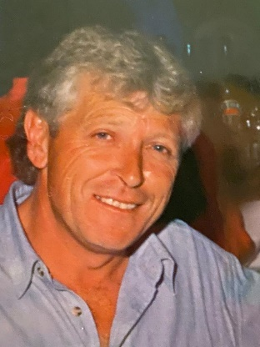
Paddy Kelly (1947-2022)
The death of Paddy Kelly took place in Melbourne, Australia. The late Paddy was born in Rapla in 1947 and his family later moved to Southill. He attended Kilruane NS and then Nenagh Vocational School. In 1962 he played on the Kilruane MacDonaghs U15 team that won the North Rural title with a victory over Borris-Ileigh and ten days later he added another divisional medal when the Magpies overcame Nenagh in the Urban Rural final. To complete a great year he collected a County Urban Rural medal when Kilruane got the better of Moyne Templetuohy in Nenagh. Paddy lined out at right wing-back in those victories. In the 1965 minor final he wore the number seven jersey as MacDonaghs relinquished their title to Roscrea. The match report gives him honourable mention. In 1966 he took the boat to England and two years later he headed to Melbourne. In 1970 he joined the army and saw active service in Vietnam. Paddy was wounded by an exploding land mine, losing the sight of one eye. After months of rehabilitation Paddy continued to play hurling with the Sinn Féin club and football with St. Kevin’s. He refereed for many years in Melbourne and served on the Gaelic Park Committee. The Kilruane MacDonaghs club extends sympathy to his sister Mary Maher, Southill, his brother Bill, Nenagh and to Paddy’s family in Melbourne. Leaba i measc na naomh dó.
Mackey Keogh (1950-2021)
The parish was stunned on Christmas morning when news filtered through that Mackey Keogh, Ballygibbon had died suddenly. He was a lionhearted hurler and a larger than life character both on and off the field. Mackey first came to prominence on the 1964 U15 Juvenile team that won two North championships and the County Rural final. He lined out in the forwards on a side that also included his older brother Johnny. Mackey progressed on to the minor and U21 teams but Kilruane MacDonaghs were not among the honours in those years. Mackey collected his next medal when he was centre-field on the U21 football team that won the club’s first title in that grade in 1970.
Mackey made his debut for the Kilruane MacDonaghs seniors in 1970 and he was ever present on the side until his retirement at the end of the 1984 season. He played in the 1973 and 1975 County finals when Kilruane lost out to Roscrea and Moneygall. He was an integral part of the MacDonaghs team that won the three-in-a-row North and County finals (1977-1979). Mackey and Seamus Hennessy formed a formidable midfield partnership on those successful sides. As a pair of club midfielders there were not many as good and certainly none better.
In 1980 a last-minute goal saw Roscrea deprive Kilruane MacDonaghs of the four-in-a-row. Mackey continued playing until 1984 without further reward. He had played for fifteen consecutive seasons as a senior player. Mackey was involved in some memorable games in Nenagh and Semple Stadium, particularly against Roscrea and Borris-Ileigh who were our great rivals at that time. He relished the physical exchanges. Mackey had few peers as a ground hurler, whipping the ball like an Exocet missile first time into the forwards. Direct hurling was his forte. Mackey was as strong as an ox. Hard work built that strength. Mackey used that strength to great effect under the dropping ball. He could bat the ball as far as most players could hit it.
When he was diagnosed with cancer he overcame his illness with the same courage and resilience that he had shown on the field. Mackey was a prolific fundraiser for Cancer Charities and the Children’s Hospital
As a mark of respect the Tricolour flew at half-mast in MacDonagh Park. Nenagh Golf Club, where Mackey was a member since 1974, formed a Guard of Honour as the funeral arrived for Mass in Kilruane. His coffin was draped in the club colours and on Mackey’s final journey to Cloughjordan cemetery MacDonaghs members flanked the funeral cortege from MacDonagh Park to the church.
Sympathy to his wife Ann, his daughters Hazel and Marcella, his son Kevin, his brothers Connie, Johnny & Bunny and extended family. Leaba I measc na naomh dó.

Thos McCormack (1949-2022)
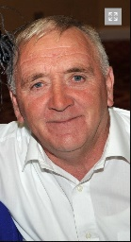
The club extends sympathy to the family of the late Thos McCormack, MacDonagh Avenue and formerly Brownstown, Cloughjordan. Thos won North Junior hurling and football medals in 1975 and was part of the Intermediate panel that won North and County titles in 1978. He particularly enjoyed the fun and banter at the training sessions in MacDonagh Park. Thos worked with North Tipperary County Council for many years and was a very conscientious and reliable employee. As a mark of respect the Tricolour flew at half-mast in MacDonagh Park. His coffin was draped in the MacDonaghs colours and club members formed a Guard of Honour as his funeral arrived in Cloughjordan. Suaimhneas síoraí dó.

Paddy Mulrooney (1937-2022)
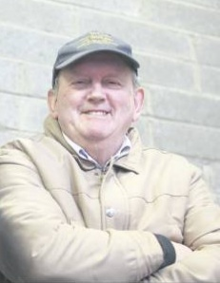
The late Paddy Mulrooney transferred to the Kilruane MacDonaghs Club in 1972. He had won an Offaly County senior hurling medal in 1971 when Birr ended a twenty-three year wait for the Sean Robbins Cup by overcoming St. Rynaghs by a point in the final. Paddy played senior, intermediate and junior hurling with MacDonaghs. In 1974 he was corner-back on the junior team that lost out to Knockshegowna in the North final. The following year he lined out at full-back when Kilruane pipped Templederry by a point in the divisional final. In 1978 Paddy was a member of the intermediate panel that won both the North and County titles. He was involved as a junior selector in 1982. Paddy was a very reliable and conscientious gatechecker with the North Board for many years. He was a familiar presence at venues throughout the division in all kinds of weather. As a mark of respect the Tricolour in MacDonagh Park flew at half-mast. Paddy’s coffin was draped in the MacDonaghs colours and club members formed a Guard of Honour at his funeral. Sympathy to his wife Recie and extended family. Ar dheis Dé go raibh a anam.

Jim Reddan (1947-2022)
The death of Jim Reddan severed yet another link with the Kilruane MacDonaghs senior team that won three-in-a-row North and County titles 1977-1979. Hurling was in Jim’s blood. His father Jack won North senior medals with MacDonaghs in 1940 and 1944 so it was no surprise that Jim would follow in his footsteps. In 1960 Jim was part of the juvenile squad that overcame Moneygall in the North final and the following year he lined out at corner-back in another victory over our neighbours. 1962 was a vintage year for the juvenile team. Jim was now marshalling the defence at number six. Victories over Borris-Ileigh in the Rural final and Nenagh in the Urban Rural final saw Jim add to his collection of North medals. That team went on to claim the County Urban Rural title with a victory over Moyne.
Jim progressed on to the minor team and was wing-back on the side that overcame Newport in the 1964 North Final. The same year he won Munster and All-Ireland Vocational Schools medals with North Tipperary. Jim made his senior debut in 1969. He moved to Carrigatoher in 1972 and threw his lot in with Burgess for three years. In 1975 Jim set anchor in his native parish once more and resumed his career in the black and white jersey. That year he was part of the senior football panel that claimed the County title at the expense of Loughmore. In 1977 he was to play a crucial role as the Frank McGrath and Dan Breen Cups were captured. His three goals in the victory over reigning champions Moneygall helped ignite the season. Jim collected two more North and County medals in 1978 and 1979. He retired at the end of the 1979 season. In 1994 he was a selector on the U14 ‘B’ football team that won the North final.
Jim was the model team player. He played where he was asked. What you saw was what you got with Jim. There was no pretence. Jim used his power and strength to great effect. He was humble and modest. Jim recognised his strengths and was very much aware of his limitations as a player. He gave his best in the black and white jersey, enjoyed his hurling but it wasn’t life or death for him.
As a mark of respect the Tricolour flew at half-mast in MacDonagh Park. His coffin was draped in the MacDonaghs colours and club members formed a Guard of Honour as his funeral arrived in Ardcroney. Sympathy to his sons Jim, Robert, Declan, Michael, John, Dan and Nigel, his daughters Caroline and Majella, his brothers John, Michael, Denis and Phil, his sister Margaret and extended family. Ar dheis Dé go raibh a anam.

Billy Sheppard (1944-2022)
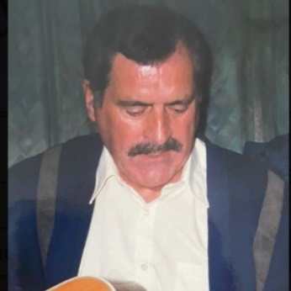
Billy was a member of the 1959 U15 squad, captained by Len Gaynor, that won the North final with a victory over Toomevara and got the better of Grange in the County Final. He won a North senior football medal in 1972 when Kilruane MacDonaghs overcame the challenge of Silvermines. Billy was very active in the Cloughjordan soccer club serving as a player, manager and secretary. He was also a talented musician and played with the Slick Six Showband in the sixties. Billy was a very committed member of the Cloughjordan Church Choir and in 2017 he was the recipient of a presentation in recognition of his many years of service. As a mark of respect the Tricolour in MacDonagh Park flew at half-mast. His coffin was draped in the MacDonaghs colours and club members together with Cloughjordan soccer club and Cloughjordan Choir formed a Guard of Honour on his last journey to the church. Sympathy to his wife Nancy and extended family. Go soilsí solas na bhFlaitheas air.
Michael Waters (1953-2022)
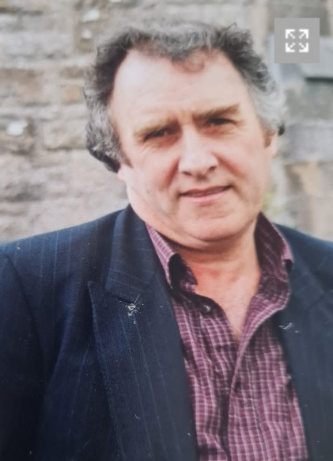
The late Michael Waters, Windmill, Cloughjordan was born on 31st May 1953. At an early age it was obvious that he had the talent to make it as a hurler. Hurling was in his DNA. His father Jim had played with Knockshegowna and was on the first Knockshe team that won a North Junior final in 1934. Jim transferred to Kilruane MacDonaghs when he married Nellie Burns and settled in the Windmill. He won North senior medals in 1940 and 1944. Michael’s uncles Billy, Tony and Joe Burns also played with the club. Michael played his first juvenile game for Kilruane MacDonaghs against Shannon Rovers in Ballinderry in 1966. He won his first medals in 1968 when he captained the U15 team, that included his brother Mackey, to win the North Rural and Urban/Rural titles against Shannon Rovers.
In 1971 he was centre-back on the minor hurling team that won the North title with a victory over Naomh Cualann (Borris-Ileigh/Templederry) and the County final against Boherlahan. A year later Michael was wing-back on the U21 hurling team that won the club’s first ever title in that grade with a victory over Roscrea in the final. Michael went on to collect two more North U21 hurling medals and two County medals (1973 & 1974). He played at midfield in the famous 1974 County U21 victory over Thurles in Nenagh. Michael had a preference for hurling rather than football but he enjoyed great success with the big ball winning North (1972) and County (1975) senior medals, three U21 medals (‘70, ’73 & ’74) and a minor medal (‘70). After his underage hurling days Michael progressed on to the junior team. He was corner-forward on the team that overcame Templederry to win the divisional title in 1975. Michael retired from hurling at the end of the 1975 season after a short but very successful career. He was a stylish hurler who operated in defence but had the ability and versatility to fill any position on the field.
In retirement, Michael remained a faithful follower of Kilruane MacDonaghs. Even in later years, when his health deteriorated, he kept in touch with the progress of all club teams. He was a mine of information on the GAA as he was an avid reader of match programmes and yearbooks. Michael supported every draw, raffle and fundraising venture that the club had. He were not afraid to put his hand in his pocket and dig deep. Michael was a very highly respected member of the local community and the huge crowds that attended his funeral were an eloquent testimony to his popularity.
As a mark of respect the Tricolour flew at half-mast in MacDonagh Park and a minute’s silence was observed before the start of the junior semi-final between Kilruane MacDonaghs and Borris-Ileigh. His coffin was draped in the MacDonaghs colours and club members formed a Guard of Honour as Michael made his final journey to Ss. Michael & John’s Church. Sympathy to his brother Mackey, sister Mary, Paddy, Jamie, Shane, Elaine, Lisa, Peggy, Jane and extended families. Suaimhneas síoraí dó.

2022
- County Senior Hurling Champions
- North Junior ‘B’ Football Champions
- North U17 ‘B’ Football Champions
- North U13 ‘A’ Hurling Champions
- North U13 ‘D’ Hurling Champions
- County U13 ‘A’ Hurling Champions
- County U13 ‘D’ Hurling Champions
- Kilruane NS County U11 Hurling Champions
- Cloughjordan North U13 Football champions
- Ardcroney NS North U13 Football Champions
- Ardcroney County NS Primary School GAA Quiz Champions
Buíochas

Thanks to all who worked for Kilruane MacDonaghs in 2022. A special word of thanks to June Whelan who took action photos of the Junior ‘A, Junior ‘C’ and U19 matches.
Memorable Day
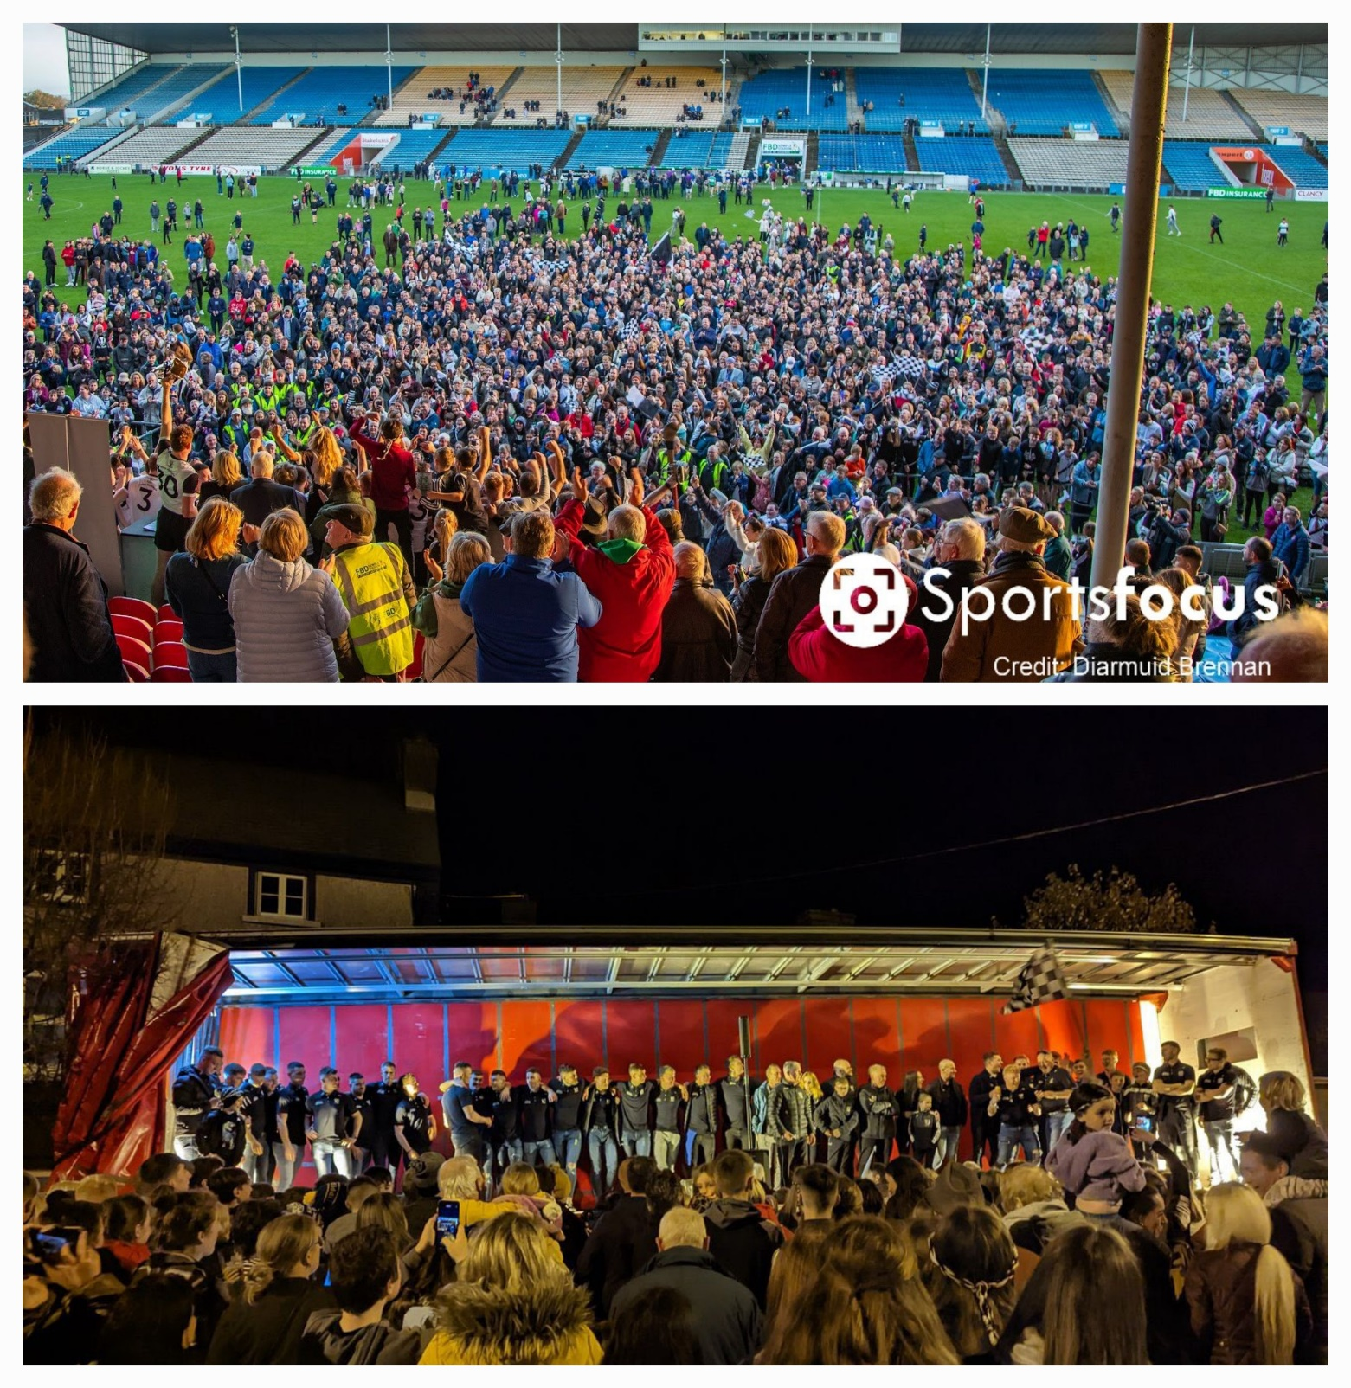

Memorable Night

