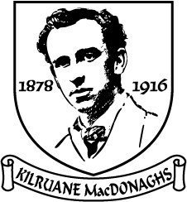
Tuairisc an Rúnaí
2018
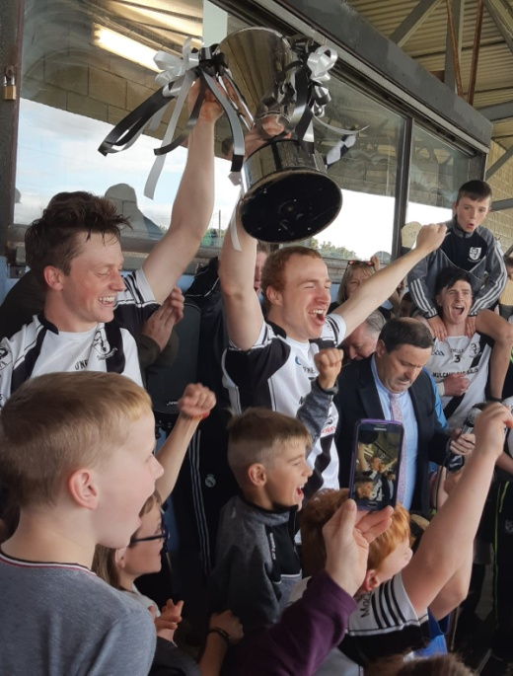
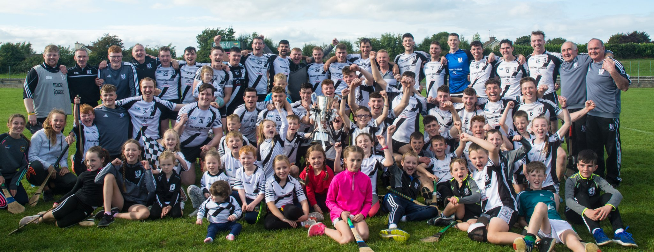
Club Officials 2018

Presidents: Tom Cleary, Tom McLoughney, Len Gaynor & Fr. Enda Burke
Vice-Presidents: Martin O’Meara, John Heenan R.I.P. , Carmel Daly & Joe McCarthy
Chairman: Joe Whelan
Vice-Chairman: Matt Cleary
Secretary: Mary McLoughney
Assistant Secretary/PRO: Gilbert Williams
Treasurer: John Mulcahy
Assistant Treasurer: Michael Cahill
Registrar: Carmel Daly
Child Welfare Officer: Yvonne O’Looney
County Board & North Board Delegate: Gilbert Williams
Injury Claims Officer: Kay Cahalan
School Liaison Officers: John O’Meara, Brian England, Barney Naughnane & Gilbert Williams
Roll of Honour
All-Ireland Club 1
All-Ireland Sevens 1
Munster club 1
56 County Titles
158 North Titles

Senior Hurling

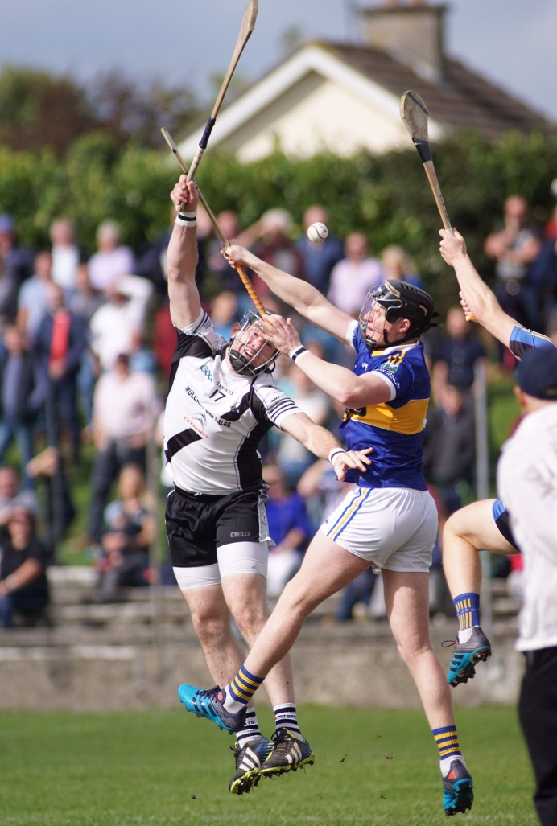
Sunday 16th of September will live long in the memory of MacDonaghs supporters as the twenty-eight year senior famine came to an end and the Frank McGrath Cup returned to the parish for the first time since 1990. The team gave its best performance for many a day and the victory sparked tremendous celebrations throughout the parish and indeed across the globe as our exiles rejoiced in this latest triumph. The team won in style and the years of misery and frustration were forgotten as the North senior title came to the parish for the 19th time. Years of hard work by many people had final finally paid off and the Magpies were senior kingpins in North Tipperary once more.
Billy O’Shea took up the reins as manager once again in 2018. Cormac McGrath was recruited as coach and Pat McLoughney was drafted in as selector. Eamon O’Shea also played a vital role in the coaching set-up and as the season wore on his input became more and more significant. Mark Gleeson was the strength and conditioning coach. June Whelan continued in charge of First Aid. Damien Franks (Kitman) and Jimmy Brady (Hurls) were ever present at both training and matches. We will be forever indebted to Billy and his backroom team for the sheer joy that they brought to everybody in the parish as they fashioned the team into worthy North champions
2017 was an “Annus Horribilus” on the injury front and everybody hoped that 2018 would be better in this regard. Unfortunately, we continued to be plagued with injuries. One weekend during the League campaign fourteen players were unavailable to both the senior and junior panels because of injury. When Jack Peters was ruled out due to illness it seemed to be the straw that would break the camel’s back. However, to the eternal credit of the management they refused to become undaunted and by the time of the North final they had almost all of the jigsaw pieces in the right place. A terrific effort against Thurles in the County quarter-final just came unstuck in the last minute of injury time. The team and management accepted this reverse in the proper manner. No blame was apportioned and no excuses were made. All agreed that they would learn from this experience.
2019 will bring fresh challenges. We will now have a target on our back whenever we play. We have a talented squad of players who have proved that they can deliver on the big stage. Competition for places is going to be ferocious and this can only lead to higher standards. We start at the bottom of the hill next year in an effort to retain the Frank McGrath and go further in the County championship. We are fortunate that we have a very professional management set-up with Billy O’Shea at the helm and Eamon O’Shea providing the x-factor on the coaching front. We all have a duty to get behind the team and management in 2019 and create a positive environment in which the team can challenge for top honours again.

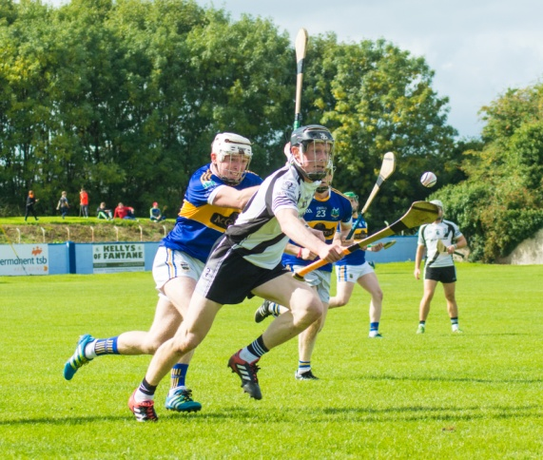
County League
Saturday 10th March in Kilcolman
Kilruane MacDonaghs 1-18 Burgess 0-21

Saturday 24th March in Newport
Kilruane MacDonaghs 3-22 Newport 1-17

Sunday 13th May in Templemore
Kilruane MacDonaghs 1-19 JK Brackens 1-14

Wednesday 13th June in MacDonagh Park
Kilruane MacDonaghs 3-18 Lorrha 1-16
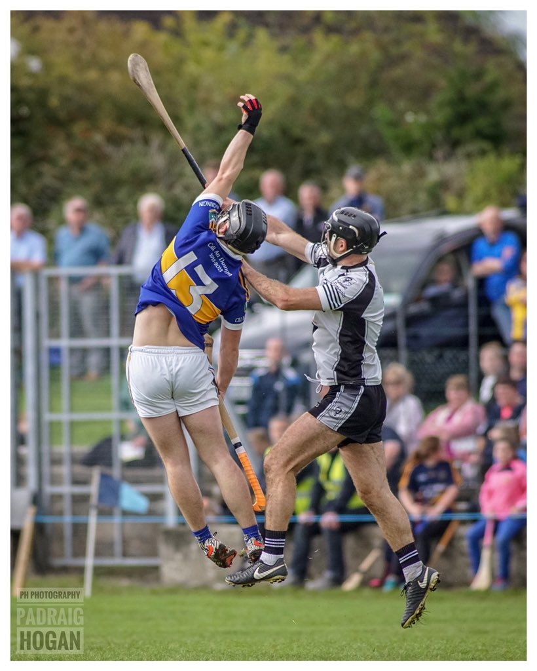
Sunday 24th June in Holycross
Kilruane MacDonaghs 2-25 Holycross 0-17

Wednesday 11th July in MacDonagh Park
Kilruane MacDonaghs 2-26 Templederry 1-23 (AET)

Wednesday 1st August in Moneygall
Loughmore 4-14 Kilruane MacDonaghs 3-16 (Final)

County Championship
Sunday 15th April in Dolla
Toomevara 1-9 Kilruane MacDonaghs 0-10

Saturday 11th August in Templetuohy
Killenaule 2-24 Kilruane MacDonaghs 3-16
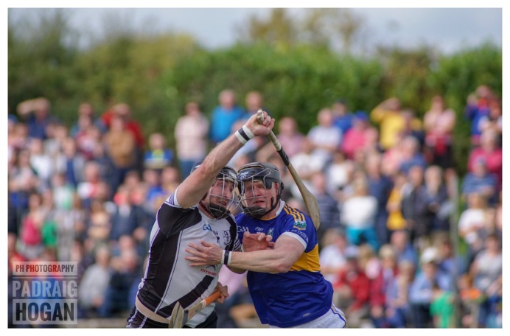
Sunday 2nd September in Dolla
Kilruane MacDonaghs 1-19 Annacarty 0-16

Saturday 29th September in Nenagh
Thurles 2-14 Kilruane MacDonaghs 1-16

North Championship
Saturday 21st April in Borrisokane
Kilruane MacDonaghs 3-22 Lorrha 2-14

Sunday 29th April in Dolla
Kilruane MacDonaghs 1-19 Newport 0-11

Friday 27th July in Dolla
Kilruane MacDonaghs 1-18 Toomevara 1-13 (Semi-Final)

Sunday 16th September in Nenagh
Kilruane MacDonaghs 0-19 Kiladangan 0-12 (North Final)

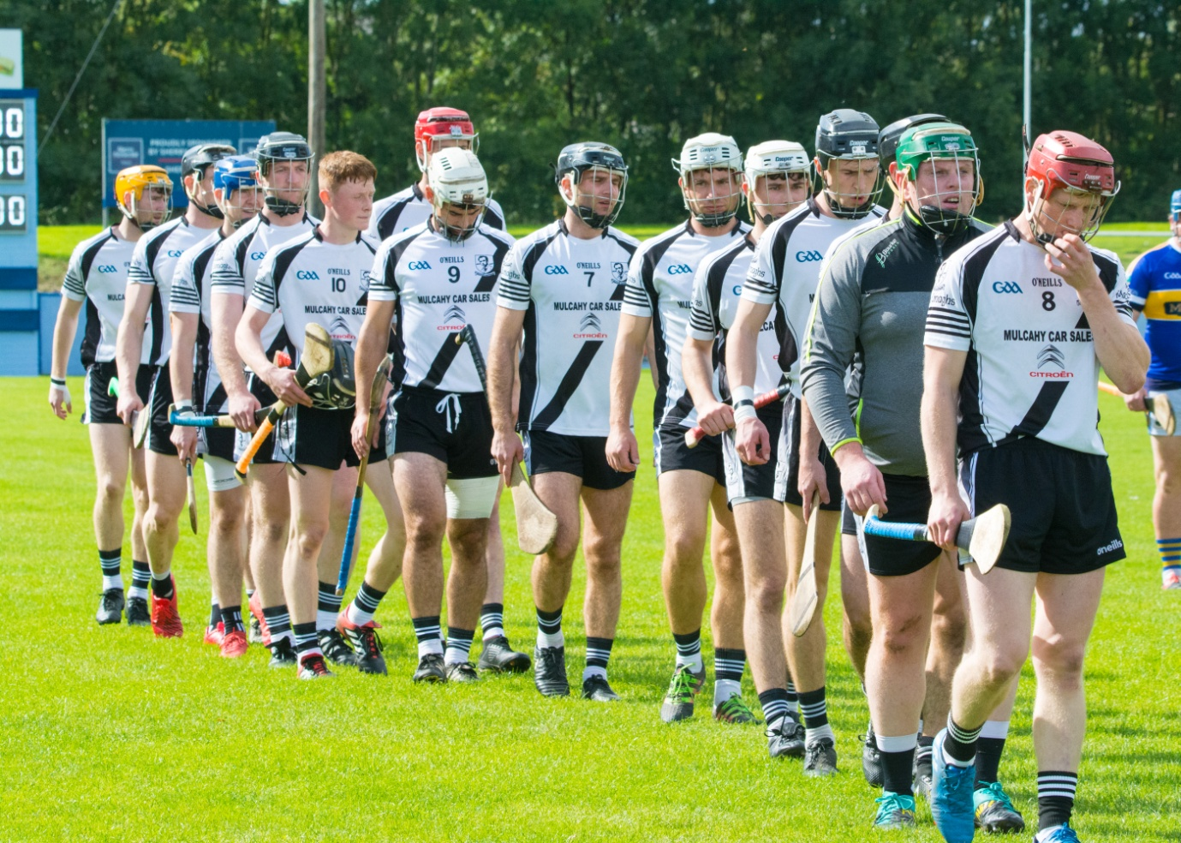
Marching into History

Junior Hurling
2018 turned out to be another disappointing year for our juniors with no victory recorded in either the League or Championship. There were some good performances in the League against Templederry and in the championship against both Roscrea and Borris-Ileigh. Similar to the senior side, this team was hampered with injuries. However, the major reason for the lack of progress with this group is the lack of bodies in the training field. There is a small group of players who train regularly; another group whose attendance at training is patchy and a third group who rarely appear in the field. There is the obvious temptation to regrade to Junior ‘B’. This would be a retrograde step by the club as we lower our standards to accommodate those players who are either unwilling or unable to train.
As we head into 2019 I would suggest that all adult players, senior and junior, start training together at the start of the year. We should only play players who regularly appear in the training field. There may be some short-term pain for long-term gain. However, I believe if the players show the required commitment we can be in contention for championship honours. Thanks to Tom Killackey, Martin Walsh and Ned Darcy for their work with this team during 2018.
.
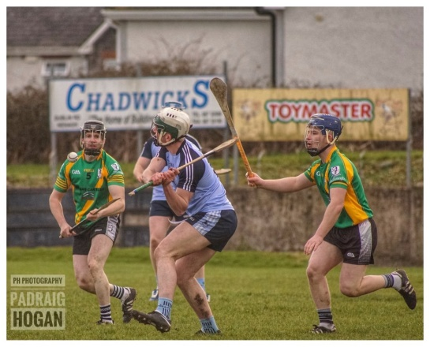
North League
Sunday 25th March in Nenagh
Nenagh 2-20 Kilruane MacDonaghs 0-12

Friday 30th March in Ballingarry
Knockshegowna 1-13 Kilruane MacDonaghs 0-9

Saturday 7th April in Templederry
Templederry 1-13 Kilruane MacDonaghs 1-12

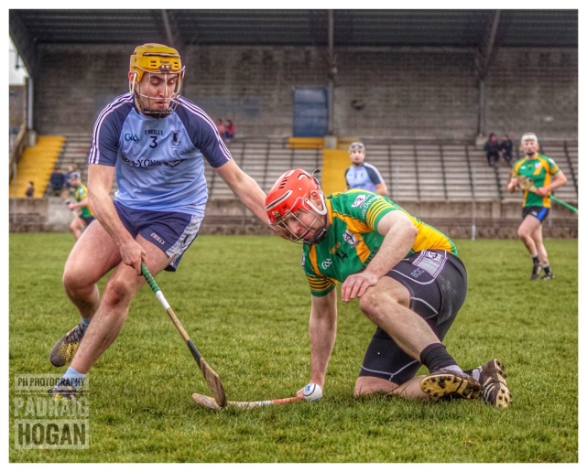
Championship
Saturday 26th May in Nenagh
Nenagh 1-19 Kilruane MacDonaghs 1-12

Saturday 9th June in Nenagh
Burgess 2-14 Kilruane MacDonaghs 1-13

Sunday 1st July MacDonagh Park
Knockshegowna 1-15 Kilruane MacDonaghs 1-7

Friday 6th July in Puckane
Roscrea 4-15 Kilruane MacDonaghs 1-16

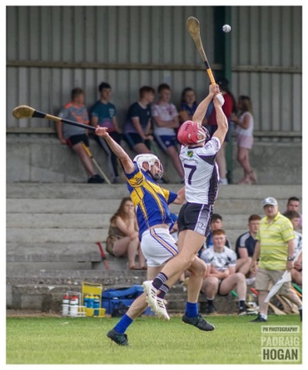
Friday 13th July in Toomevara
Borris-Ileigh 2-23 Kilruane MacDonaghs 1-21

Sunday 22nd July in MacDonagh Park
Lost to Toomevara

Minor Hurling

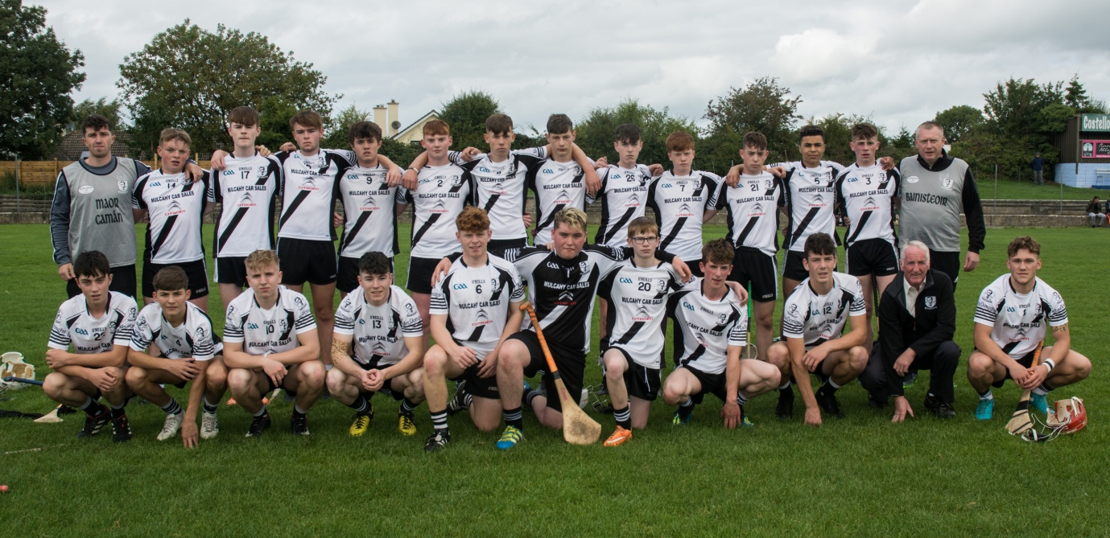

For seventeen years (2002-2016) our minors have plied their trade in the in the ‘A’ grade. Last year the club decided to affiliate the minors in the ‘B’ championship. This turned out to be a wise decision as they would have been out of their depth in the premier competition. There were a number of fancied teams in the ‘B’ championship and MacDonaghs were considered outsiders. Against the odds they claimed the title. They showed great heart and determination to come from behind to force a draw against Burgess in the second group game. In the semi-final against Borrisokane they came from seven points down against the wind to force extra time and eventually book a spot in the final. Their victory in the North final against Silvermines heralded a fantastic week for the club. That success demonstrated that the spirit for which this club is renowned was alive and well. The semi-final against Drom & Inch was a bridge too far. It had been a fantastic year for this group. Thanks to the Damian Mulcahy (Manager), Niall O’Meara (Coach) & John Quinlan and Eanna Hogan (Selectors). Next year will see a new challenge for the minors as we return to the premier grade.

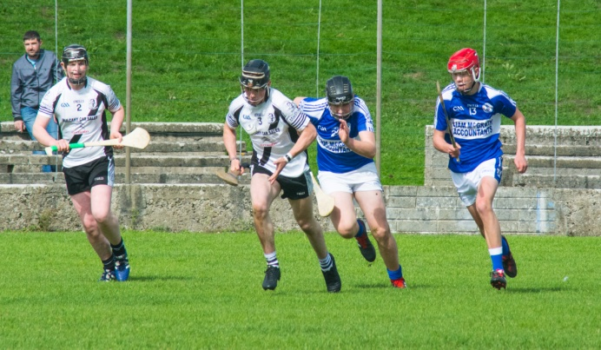
Thursday 12th April in Borrisokane
Kilruane MacDonaghs 0-14 Borrisokane 1-11

Thursday 5th July in Nenagh
Kilruane MacDonaghs 1-18 Burgess 1-18

Thursday 12th July in MacDonagh Park
Kilruane MacDonaghs 4-20 Templederry/Ballinahinch 3-16

Thursday 16th August in Puckane
Kilruane MacDonaghs 2-18 Borrisokane 2-16 (Semi-Final)
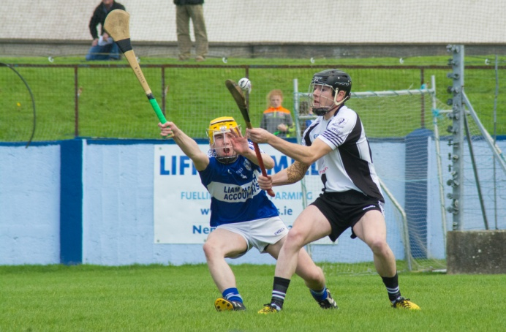

Sunday 9th September in Nenagh
Kilruane MacDonaghs 0-12 Silvermines 0-11 (North Final)

Sunday 30th September in Templederry
Drom & Inch 3-13 Kilruane MacDonaghs 0-8

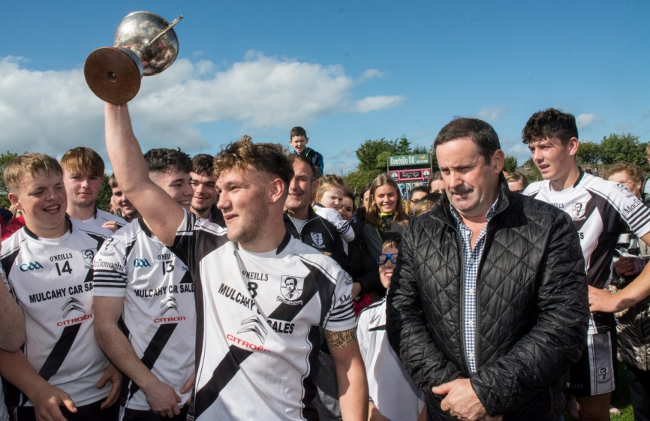

Under 21 Football
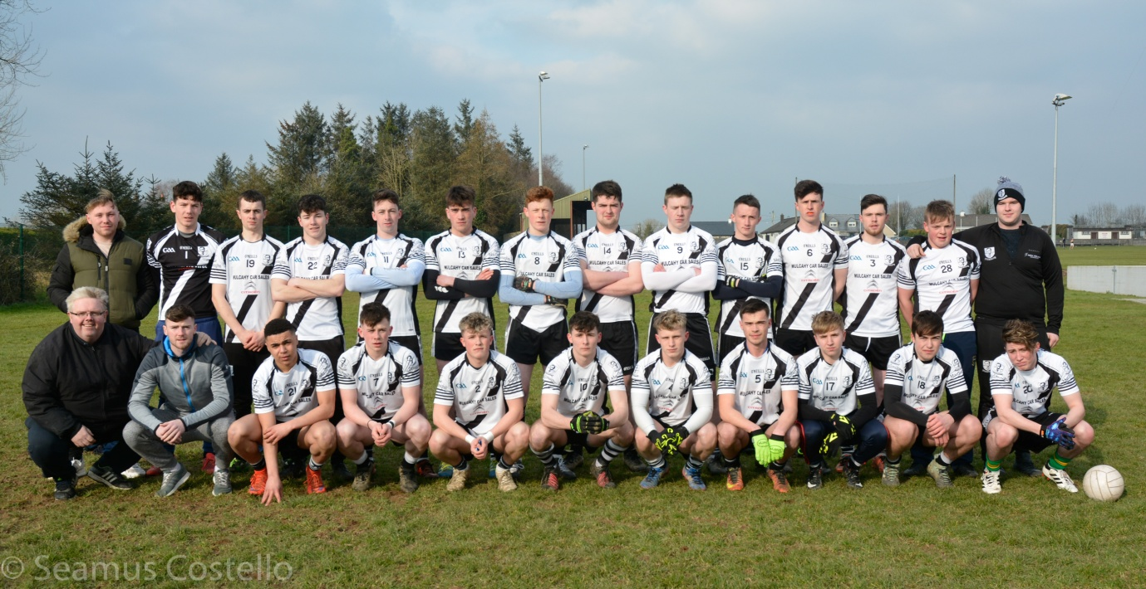

The club decided to enter a team in this competition for the first time since 2007. We were drawn away to Silvermines in the semi-final of the ‘B’ championship and had a comfortable victory. We were on the road again for the final and just lost out by the minimum of margins to Newport. Unfortunately, we were without the services of Cian Darcy for both matches. He was on the Tipperary senior panel at the time and was not available for selection. The early start to this competition with the likelihood of bad weather puts pressure on the availability of pitches. Thanks to Brian O’Meara (Manager) and selectors Tom Killackey & Ned Darcy for their work with this team.

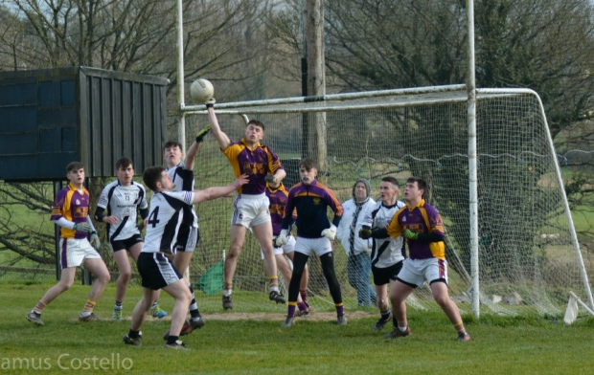
17th February in Dolla
Kilruane MacDonaghs 2-12 Silvermines 1-0

Saturday 24th February in Newport
Newport 2-9 Kilruane MacDonaghs 3-5 (North Final)

Minor Football

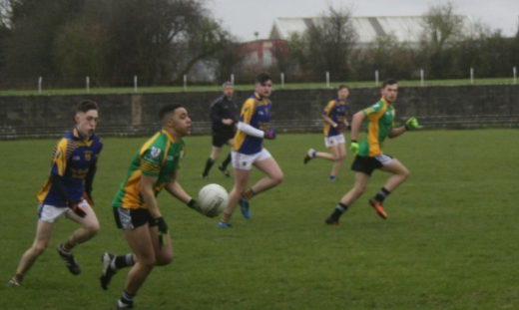
After winning the North & County ‘B’ titles in 2017 we moved into the ‘A’ grade for 2018. A great victory in the semi-final against a fancied Kiladangan outfit ensured a spot in the decider against Inane Rovers. The final score in that game didn’t reflect the trend of play but there can be no dispute that the better team won. Thanks to Damian Mulcahy (Manager), Niall O’Meara (Coach) & selectors John Quinlan and Eanna Hogan.

Saturday 10th March in MacDonagh Park
Kilruane MacDonaghs 3-6 Kiladangan 2-7

Saturday 17th March in Roscrea
Inane Rovers 4-12 Kilruane MacDonaghs 0-5 (North Final)

Under 21 Hurling

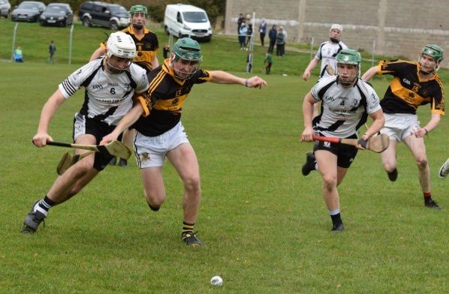
The first round game against Moneygall/Clonakenny was called off after about twenty minutes when Kevin Shinners sustained a neck injury. Happily, Kevin’s injury was not as serious as was feared but the correct decision was taken to terminate the game. MacDonaghs were 0-7 to 0-3 ahead at this stage. In the refixture the Magpies had a rather flattering five-point victory with a number of players struggling to find their form. A tremendous second half performance against Nenagh booked a place in the final. MacDonaghs dominated the opening half in the decider against Toomevara. However, they faded in the second half and Toomevara emerged worthy winners. Thanks to the management team of Brian O’Meara, Tom Killackey, Ned Darcy & June Whelan (First Aid) for all their efforts during the year.

Saturday, 20th October in Toomevara (Refixture)
Kilruane MacDonaghs 2-17 Moneygall/Clonakenny 0-18

Sunday 18th November in Borrisokane (Semi-Final)
Kilruane MacDonaghs 0-16 Nenagh 0-12

Sunday 25th November in Borrisokane (North Final)
Toomevara 0-14 Kilruane MacDonaghs 0-10

County Representation
Senior: Niall O’Meara
Under 21: Cian Darcy, Jerome Cahill & Craig Morgan (All-Ireland Medallists)
Minor: Kian O’Kelly (Munster Medallist)
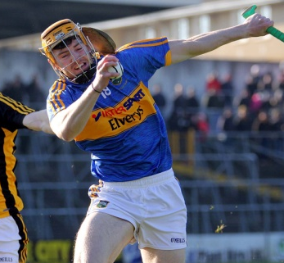
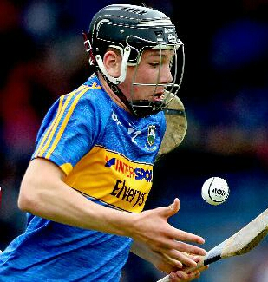
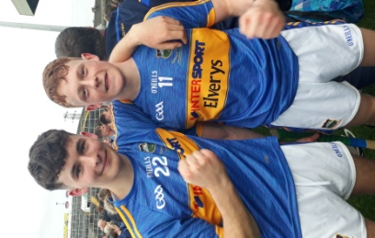

Committee
Throughout the club we have a large group of volunteers doing tremendous work as officials, selectors, coaches, Lotto Promoters, County Draw Promoters etc. The engine room of the club is the committee. It needs to have active and committed members. In 2018 there were eight meetings of the committee with an average attendance of 13. The highest attendance was 17 and the lowest 10. This committee needs to be rejuvenated. We should aim to have 25 members on the committee for 2019.

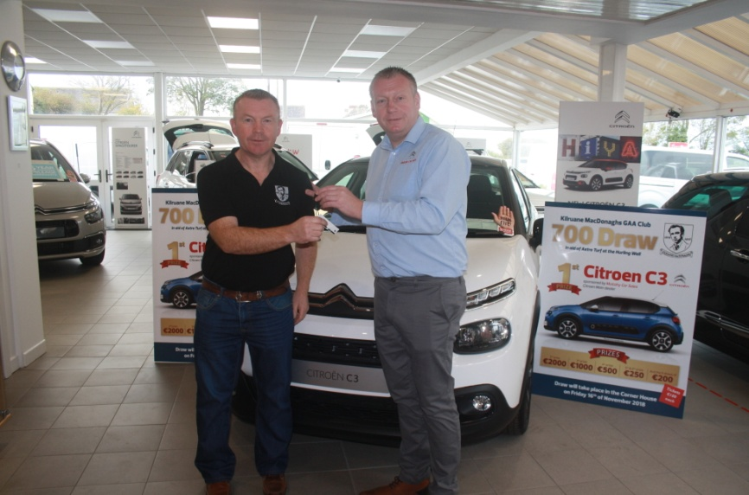
Thanks to our Main Sponsor Mulcahy Car Sales
Mulcahy Car Sales Ardcroney
Sympathy to all who suffered bereavement during 2018

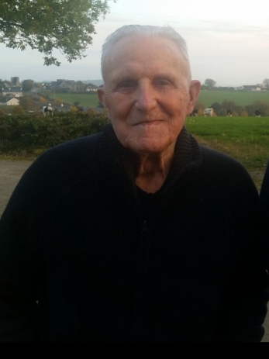

Joe Burns Sean McLoughney John Heenan
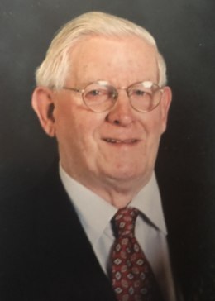
(1934-2018) (1944-2018) (1925-2018)

John Ryan Sean Hyland Paddy O’Meara
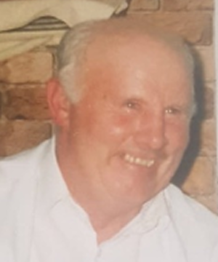
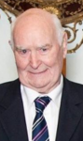
(1935-2018) (1942-2018) (1928-2018)
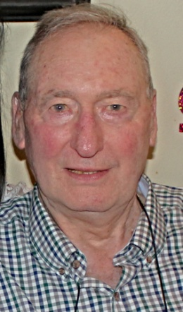
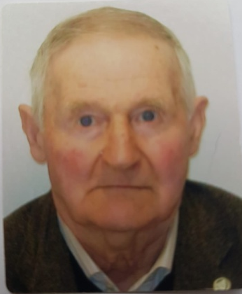

Jim Hensey Kevin Gaynor
(1929-2018) (1935-2018)

No Words Needed
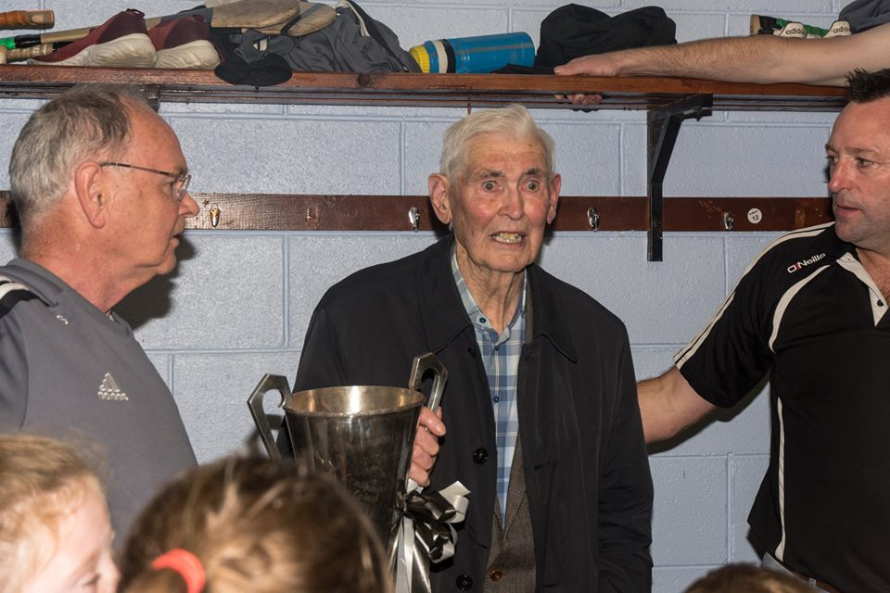

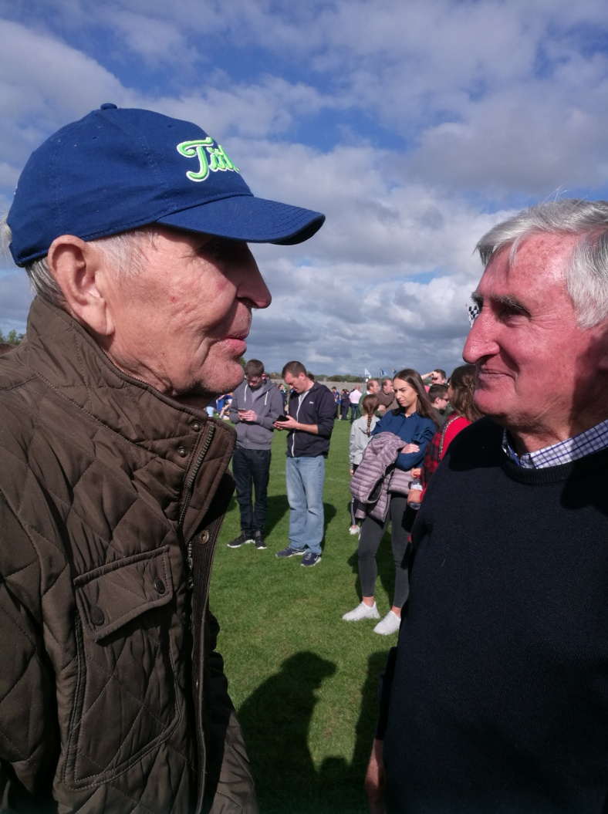

2018
North Senior Hurling Champions
North Minor ‘B’ Hurling Champions
North & County Féile ‘B’ Hurling Champions
North & County Under 14 ‘B’ Hurling Champions
North & County Under 12 ‘D’ Football Champions (Second Team)
North Under 11 ‘A’ Hurling Champions
North Under 21 ‘A’ Hurling Finalists
Jim Devitt Cup Finalists
North Under 21 ‘B’ Football Finalists
North Minor ‘A’ Football Finalists
North Under 11 ‘D’ Hurling Finalists (Second Team)
Ardcroney N.S. North & County U13 Hurling Champions
Ardcroney N.S. County Under 11 Hurling Champions
Ardcroney N.S. County Under 13 Camogie Champions
Ardcroney N.S. County Under 11 Camogie Champions
Cloughjordan Schools North & County Under 13 Football Champions
Cian Darcy, Jerome Cahill & Craig Morgan All-Ireland Under 21 Medallists
Jerome Cahill Nominee on the U21 Hurling Team of the Year
Jerome Cahill Nominee for Tipp FM Club Hurler of the Year
Kian O’Kelly Munster Minor Medallist
Cúl Camp: Attendance of 220
Development: Commencement of Astro Turf Project (€92,000)

