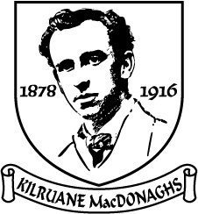

Tuairisc an Rúnaí
2017

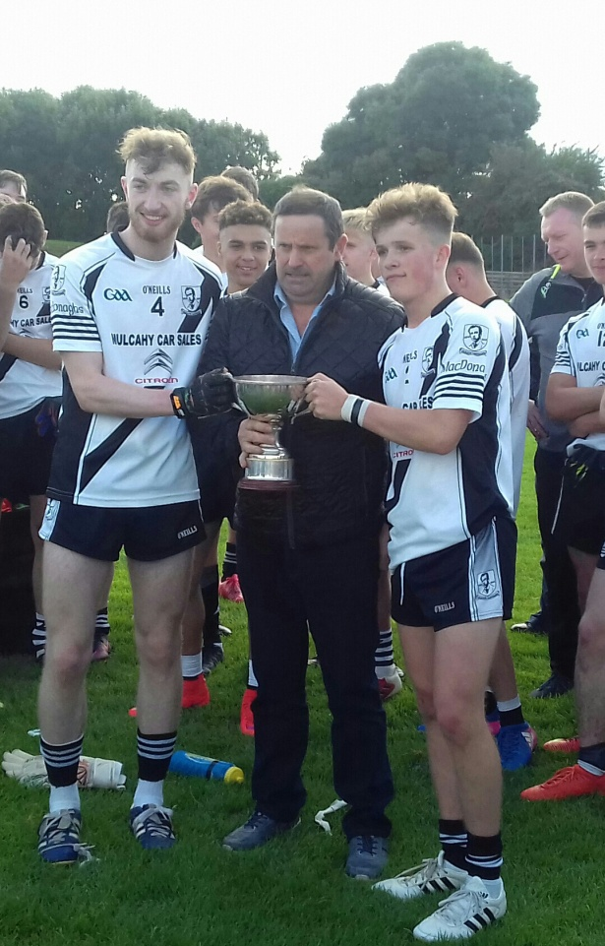

Club Officials 2017

Presidents: Tom Cleary, Paddy McCarthy RIP, Tom McLoughney & Fr. Enda Burke
Vice-Presidents: Martin O’Meara, John Heenan, Carmel Daly & Joe McCarthy
Chairman: Matt Cleary
Vice-Chairman: Joe Whelan
Secretary: Mary McLoughney
Assistant Secretary/PRO: Gilbert Williams
Treasurer: John Mulcahy
Assistant Treasurer: Michael Cahill
Registrar: Carmel Daly
Child Welfare Officer: Yvonne O’Looney
County Board & North Board Delegate: Gilbert Williams
Injury Claims Officer: Kay Cahalan
School Liaison Officers: John O’Meara, Brian England, Barney Naughnane & Gilbert Williams

Roll of Honour
152 North Titles
53 County Titles

Senior Hurling
Billy O’Shea returned as manager for 2017. Shane McGrath was recruited as coach and Kevin O’Brien was drafted in as selector. Eamon O’Shea also played a vital role during the year with some invaluable sessions in MacDonagh Park. Kevin Quinlan took charge of strength and conditioning. June Whelan continued in charge of First Aid while Ger Corcoran was present on match days as physio. Damien Franks (Kitman) and Sean Kelly (Hurls) were ever present at training and match days and Carmel Daly looked after the catering at training when required. As in previous years a very professional setup was in place for our senior team. No effort was spared by club and management in an effort to make the breakthrough.
However, nobody can legislate for injuries and in this regard it was an “Annus Horribilus”. Darragh Peters, Brian O’Meara, Thomas Cleary, Willie Cleary, Éanna Hogan, Ray McLoughney and Eoin Williams were all injured at some stage. With Tomás Hogan and Stephen Cleary across the Atlantic the selectors were never able to select from a full deck. No fair assessment of the season can be made without considering the negative impact of injuries. Despite depleted resources, the team made a great start to the year with victories over Nenagh and Borrisokane and a credible performance against Thurles. A disappointing loss to Kiladangan ended North championship aspirations while a comfortable victory over Carrick Swan booked a quarter-final date with Thurles in Semple Stadium. After a sluggish start the team took the game to Sarsfields and would not have been flattered by victory in normal time. In extra time the loss of key players came home to roost as Thurles advanced.

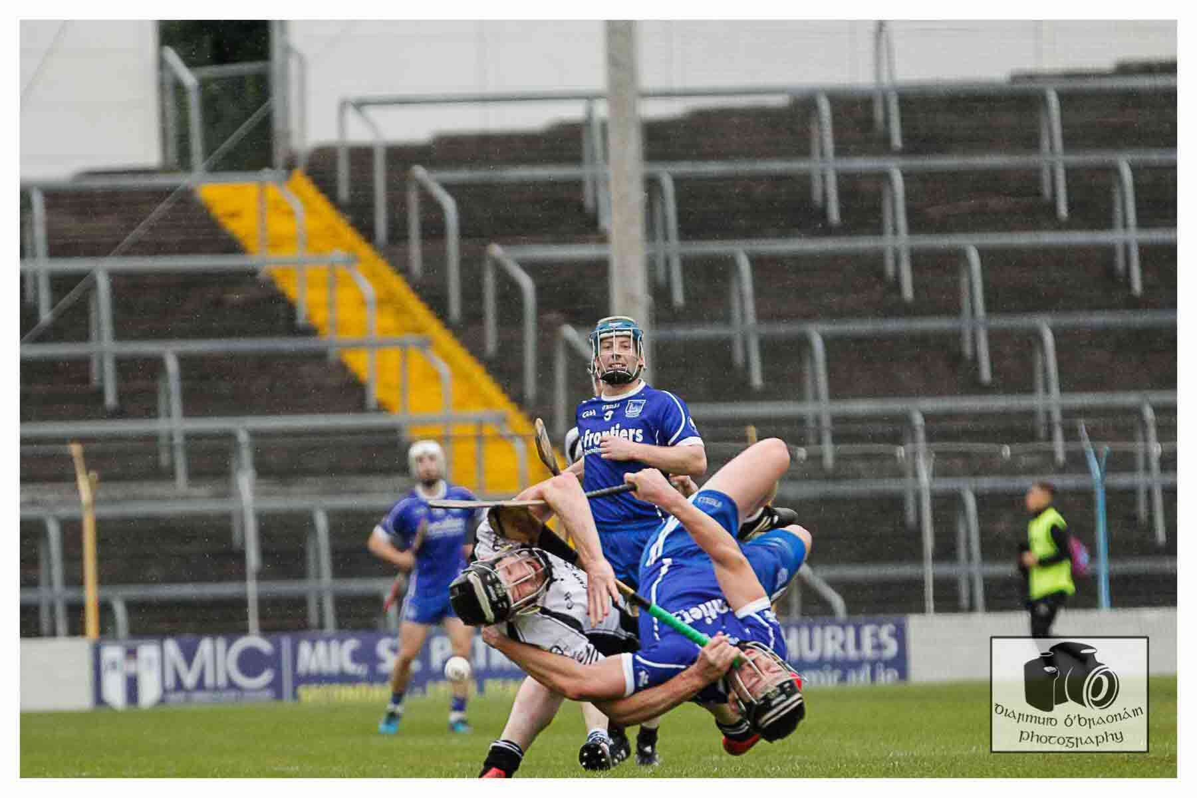

Extract from last year’s report: Prophets of doom have had their say and cast doubt on the team’s ability to make the breakthrough. Negativity can be self-fulfilling. Everybody must remain optimistic and supportive. We have, however, to be realistic. Unless we improve, success will remain elusive. A few positional and personnel changes will help enormously. However, these alone will not suffice. Every player will have to do a little better in 2017 to bring about team improvement. Some will have to seriously address fitness issues while others will need to focus on skill development and attitude.”
The above sentiments are even more relevant as we head into 2018. It is clear to everybody that some players have very serious fitness issues and are making very little effort to address them. We simply haven’t enough bodies in the field at training. The attendance record of some players is very poor. To achieve success players must set the highest of standards in everything they do. To expect to be successful with second class standards is an exercise in self delusion.

“The Price of Excellence is Discipline
The Cost of Mediocrity is Disappointment”

“

League

Round 1: Saturday, 11th March in Borrisoleigh
Borris-Ileigh 2-22 Kilruane MacDonaghs 3-11

Round 2: Saturday, 25th March in Thomas MacDonagh Park
Kilruane MacDonaghs 2-21 Kiladangan 4-13

Round 3: Sunday, 9th April in Annacarty
Kilruane MacDonaghs 0-21 Annacarty 1-14

Round 4: Saturday, 2nd July in Thomas MacDonagh Park
Drom & Inch 3-22 Kilruane MacDonaghs 1-15

Round 5: Saturday, 13th August in Thomas MacDonagh Park
Upperchurch Drombane 0-24 Kilruane MacDonaghs 2-16

North Championship

Round 1: Sunday, 7th May in Borrisokane
Kilruane MacDonaghs 0-27 Borrisokane1-13

Quarter-Final: Sunday, 11th June in Dolla
Kiladangan 2-15 Kilruane MacDonaghs 1-11

.

County Championship

Round 1: Sunday, 30th April in Toomevara
Kilruane MacDonaghs 3-17 Nenagh Éire Óg 0-15

Round 2: Sunday, 28th May in Templemore
Thurles Sarsfields 1-25 Kilruane MacDonaghs 2-15

Round 3: Saturday, 13th August in Boherlahan
Kilruane MacDonaghs 3-21 Carrick Swan 1-17

Quarter-Final: Saturday, 16th September in Semple Stadium
Thurles Sarsfields 3-26 Kilruane MacDonaghs 1-22 (AET)

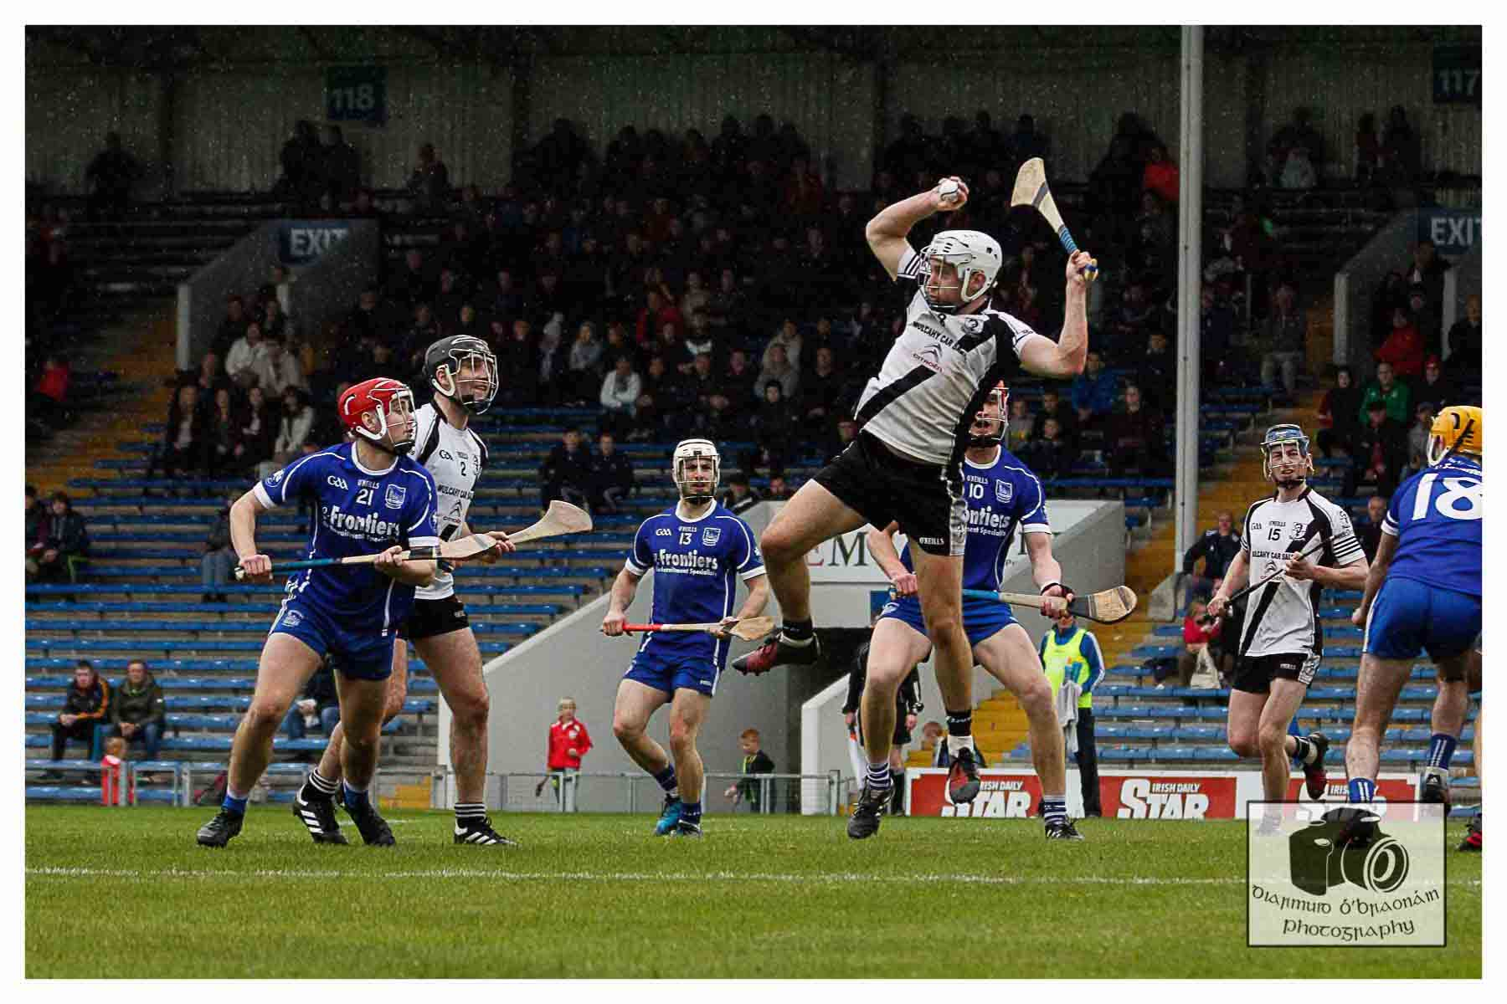
Junior Hurling

For the second year in succession the juniors failed to make it to the qualifying stages of League or Championship. With the seniors using twenty-two players while the juniors were still in the championship it was always going to be an uphill struggle for this team. Form was very patchy in both League and Championship. Good displays against Toomevara, Nenagh and Templederry in the League & spirited performances against Toomevara, Burgess and Borris-Ileigh in the Championship couldn’t camouflage some very indifferent performances in other games. Perhaps their greatest achievement was managing to field a team away to Templederry in the League on a Monday evening. A number of players travelled from Dublin for that match in what was one of their best displays of the season. If the spirit and commitment evident on that evening could have been replicated in the training field during the year a different story might have unfolded. However, “One swallow doesn’t make a summer.” Apart from the limited number of players available for selection the major problem for this team was lack of fitness. Of the starting fifteen against Knockshegowna in the championship, only four had been regular trainers throughout the season. To remedy the fitness issue, it is imperative that the juniors begin training with the seniors. The majority of this panel were conspicuous by their presence in the field during 2017. In 2018 they should be conspicuous by their absence. Thanks to Paddy Williams, Ruan Casey and Declan Souch for their efforts during the year. Managing a junior team is never an easy task and this year was no exception.

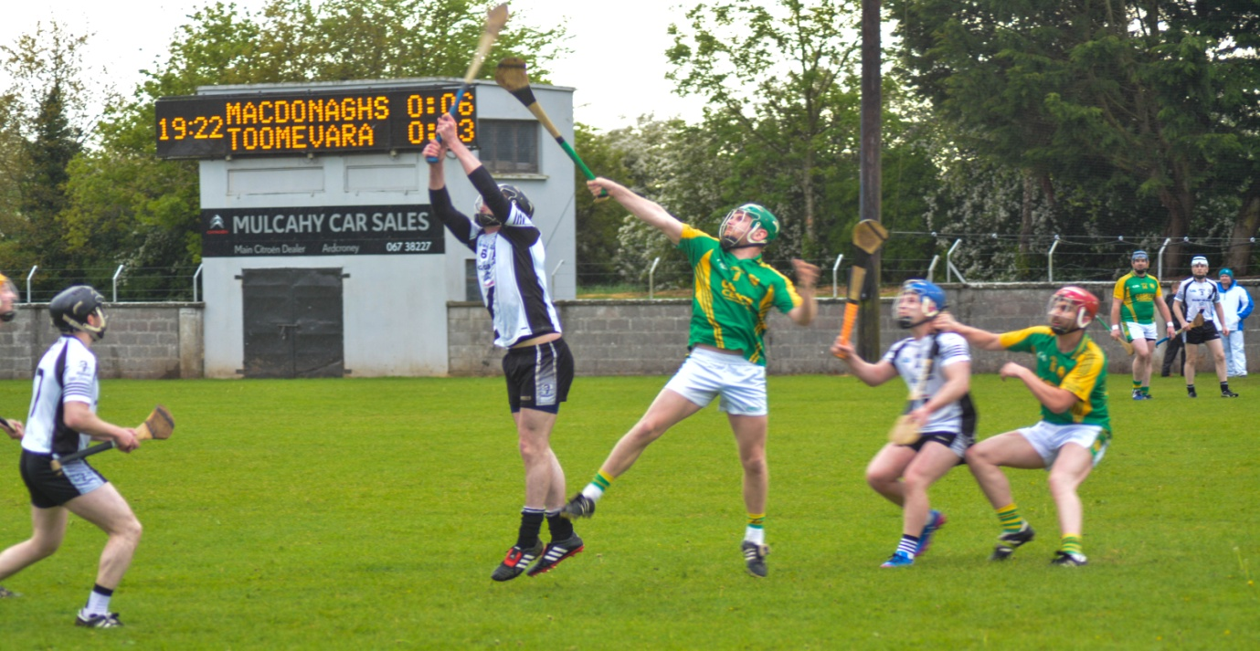

League

Round 1: Saturday, 1st April in Thomas MacDonagh Park
Kilruane MacDonaghs 0-14 Borris-Ileigh 1-9
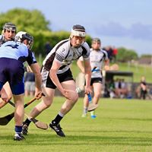
Round 2: Saturday, 13th May in Thomas MacDonagh Park
Toomevara 3-18 Kilruane MacDonaghs 1-19

Round 3: Saturday, 20th May in Thomas MacDonagh Park
Kilruane MacDonaghs 2-12 Knockshegowna 1-13

Round 4: Saturday, 3rd June in Nenagh
Nenagh 0-19 Kilruane MacDonaghs 1-15

Round 5: Friday, 16th June in Kilcolman
Burgess 3-17 Kilruane MacDonaghs 1-12

Round 5: Monday, 19th June in Templederry
Templederry 1-17 Kilruane MacDonaghs 2-10

Championship

Round 1: Friday in Thomas MacDonagh Park
Kilruane MacDonaghs 6-8 Toomevara 1-23 (Draw)

Round 2: Friday, 21st July in Nenagh
Nenagh 1-23 Kilruane MacDonaghs 0-12
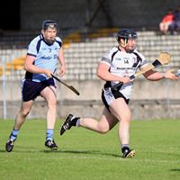
Round 3: Saturday, 5th August in Thomas MacDonagh Park
Kilruane MacDonaghs 1-16 Burgess 1-16

Round 4: Saturday, 19th August in Ballingarry
Knockshegowna 3-17 Kilruane MacDonaghs 1-13

Round 5: Friday, 1st September in Borrisoleigh
Borrisoleigh 1-18 Kilruane MacDonaghs 3-9

Minor Hurling

The minor hurlers qualified for the semi-final where they gave a very good account of themselves before giving second best to eventual North and county champions Roscrea. The loss of a number of players who had played U16 two years ago was a major handicap for the team. Nathan Lynch departed the scene during the season and the absence of Sean McAdams for the semi-final was a mortal blow to the team’s chances of progress. Ultimately, the team was depending on two few to do too much. Although, we had two of the best minors in Tipperary we hadn’t sufficient strength in depth to get over the line. Thanks to Liam O’Kelly, Damian Mulcahy, Éanna Hogan and Niall O’Meara for all their work during the year.

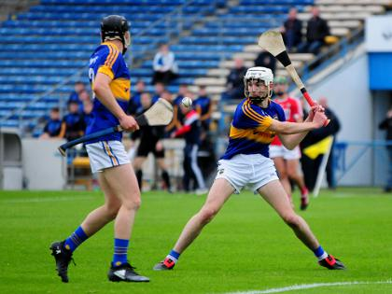

Rd 1. Friday, 14th April in Thomas MacDonagh Park
Kilruane MacDonaghs 3-15 Silvermines 2-8

Round 2: Thursday, 20th April in Roscrea
Roscrea 2-16 Kilruane MacDonaghs 2-11

Round 3: Thursday, 13th July in Thomas MacDonagh Park
Kilruane MacDonaghs 4-14 Nenagh 4-11

Round 4: Thursday, 20th July in Puckane
Kiladangan 4-17 Kilruane MacDonaghs 1-21

Round 5: Wednesday, 26th July in Thomas MacDonagh Park
Kilruane MacDonaghs 2-13 Lorrha/Rovers 0-13

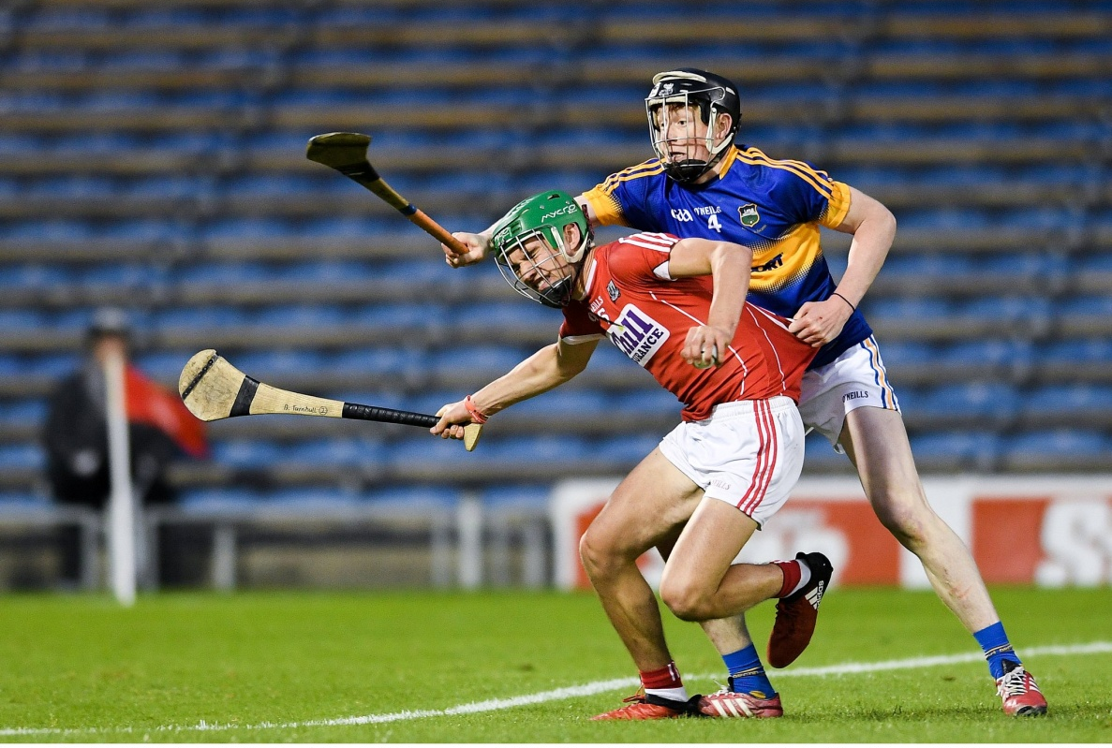
Semi-Final: Wednesday, 30th August in Toomevara
Roscrea 1-15 Kilruane MacDonaghs 0-12

Under 21 Hurling

MacDonaghs were drawn in a group of three along with Toomevara and Roscrea. In the first round Roscrea were unable to fulfil the fixture so the game against Toomevara became a winner-takes-all-affair. Without the injured Darragh Peters, MacDonaghs faced an uphill struggle in Dolla on Sunday, 12th November. Toomevara took control of the game in the first half and although Kilruane fared much better in the second half Toomevara were deserving winners on a 2-17 to 0-13 scoreline. Thirteen of the starting fifteen are underage for next year so we should be very competitive in 2018. Thanks to Brian O’Meara, Tom Killackey and Ned Darcy for their work with this team.

Minor Football

The decision to affiliate a team in this grade proved to be a very wise one as MacDonaghs went on to claim North and county honours. This side improved as the season progressed. In the North final they played some delightful football to record a comprehensive win over Kiladangan. An eventful county semi-final against Cappawhite Gaels ended in a draw. Refusal by both teams to play the mandatory extra time resulted in two “courtroom” appearances in Limerick and Thurles which overturned the decision to expel both teams from the championship. MacDonaghs made most of the reprieve with a decisive victory in the replay. However, they reserved their best performance for the county final where they overcame Moyne Templetuohy/Thurles Gaels with a scintillating display of attacking and defensive football. Thanks to Liam O’Kelly (Manager). Niall O’Meara & Pat Murphy (Coaches), Damian Mulcahy & Eanna Hogan (Selectors) and June Whelan (Physio) for all their work during a long season.

Round 1: Kilruane MacDonaghs 2-10 Templederry/Ballinahinch 0-6

Round 2: Kilruane MacDonaghs 4-10 Portroe 0-7

Semi-Final: Wednesday 26th July in Borrisokane
Kilruane MacDonaghs 2-13 Lorrha/Rovers Gaels 0-13

North Final; Monday 7th August in Nenagh
Kilruane MacDonaghs 4-11 Kiladangan 0-4

County Semi-Final; Saturday, 23rd September in Templederry
Kilruane MacDonaghs 3-3 Cappawhite Gaels 1-9

County Semi-Final (Replay): Tuesday, 21st November in Dr. Morris Park
Kilruane MacDonaghs 6-9 Cappawhite Gaels 0-9

County Final: Saturday, 9th December
Kilruane MacDonaghs 2-11 Moyne Templetuohy/ Thurles Gaels 1-3

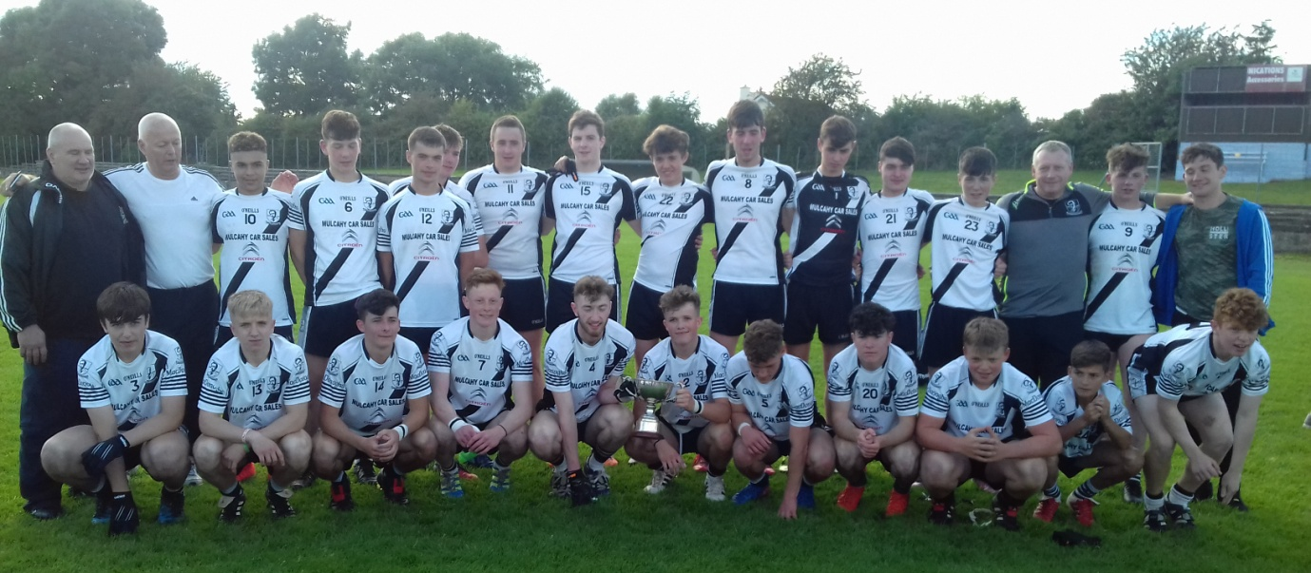

County Representation
Senior: Niall O’Meara
Under 21: Cian Darcy
Minor: Jerome Cahill & Craig Morgan
County U21 Hurling Selector: Billy O’Shea
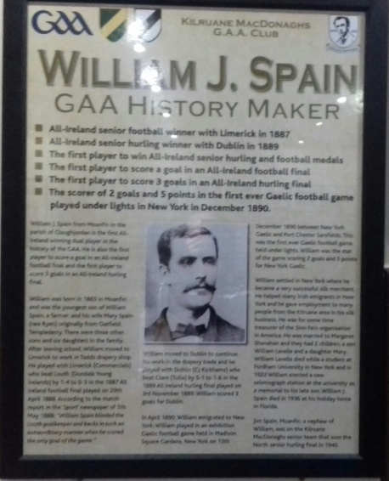
Other Highlights
Auction in the Abbey Court on Saturday, 4th March. The most successful fundraiser in the club’s history.
Unveiling of Information Board in the Clubroom to honour achievements of the legendary William J. Spain
Laochra Gael; Len Gaynor
Nenagh Guardian Hall of Fame: Len Gaynor
County Community Games Hurling Champions
Ardcroney N.S. County U13 ‘E’ Hurling Champions
Adrcroney N.S. North Tipperary GAA Quiz Winners

Thanks to our Main Sponsor
Mulcahy Car Sales Ardcroney

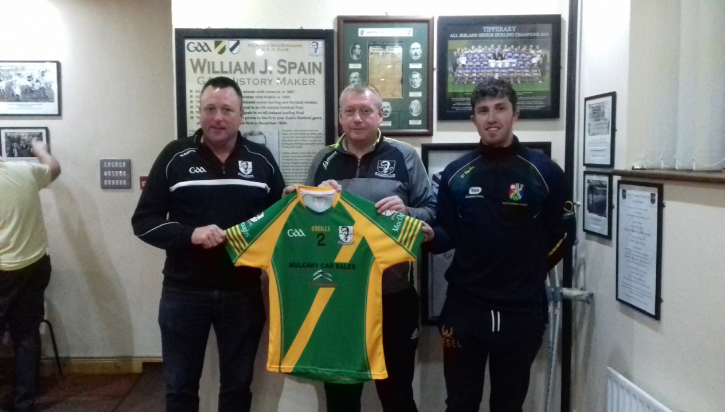

Thanks to all our Sponsors

Thanks to everybody who helped during 2017
“The Future is Bright. The Future is Black & White.”

Sympathy to all who suffered bereavement during 2017

