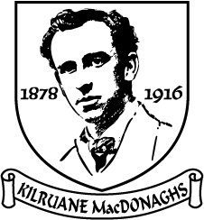
Tuairisc an Rúnaí
2019

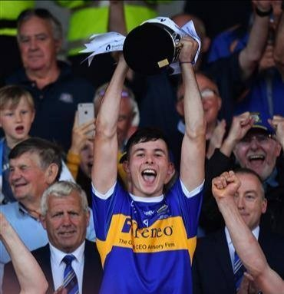

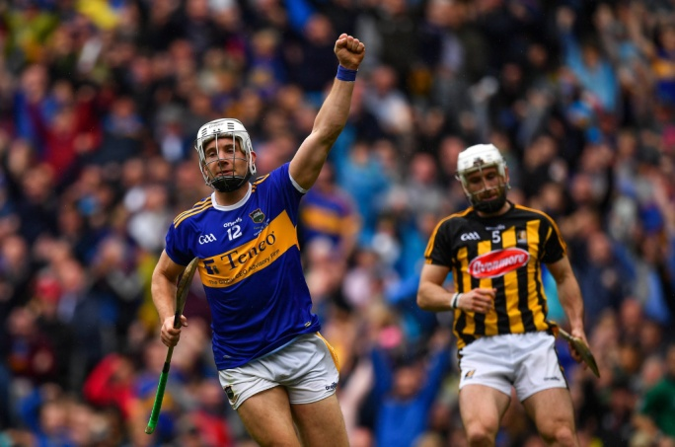

Club Officials 2019
Presidents: Tom Cleary R.I.P., Tom McLoughney, Len Gaynor & Fr. Enda Burke
Vice-Presidents: Martin O’Meara, Carmel Daly, Joe McCarthy & Fr. Pat Greed
Chairman: Joe Whelan
Vice-Chairman: Michael O’Meara
Secretary: Mary McLoughney
Assistant Secretary/PRO: Gilbert Williams
Treasurer: John Mulcahy
Assistant Treasurer: Michael Cahill R.I.P.
Registrar: Carmel Daly
Child Welfare Officer: Yvonne O’Looney
County Board & North Board Delegate: Gilbert Williams
Injury Claims Officer: Kay Cahalan
School Liaison Officers: John O’Meara, Brian England, Barney Naughnane & Gilbert Williams
Health & Well Being Officer: Dr. Róisín Costello
Roll of Honour
All-Ireland Club 1
All-Ireland Sevens 1
Munster Club 1
56 County Titles
160 North Titles

Senior Hurling

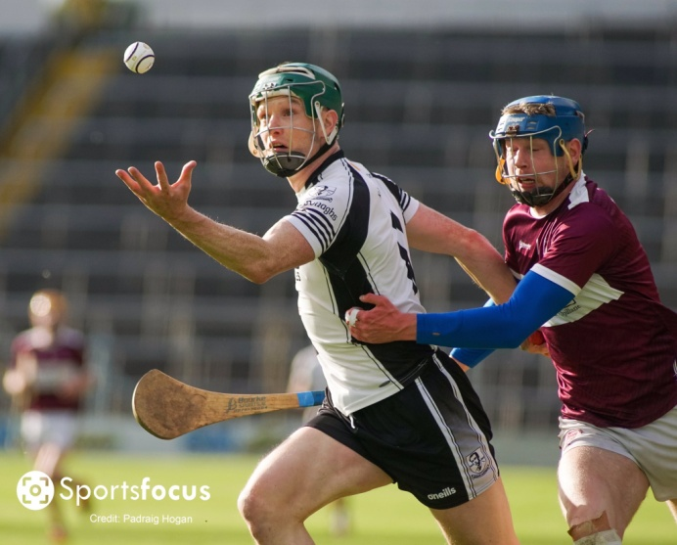
After a fantastic year in 2018 it was no surprise that they same management team was once again at the helm for 2019. Manager Billy O’Shea assembled very professional management and backroom teams. Cormac McGrath filled the role of coach with Eamon O’Shea also playing a pivotal role in team preparation. The experienced Pat McLoughney continued as a selector and acted as goalkeeping coach. John Hyland was added as an extra selector, strengthening the local input.
In what was a very difficult year for him Mark Gleeson took charge of the physical fitness. June Whelan continued in charge of First Aid. Jimmy Brady took great care of the sliotars, Martin Walsh and David Slattery were reliable kitmen while Colin England and Eoin Kennedy were part of the match days set-up. Carmel Daly looked after the catering with her usual efficiency.
Most clubs find the County League unsatisfactory and Kilruane MacDonaghs are no exception. County players are unavailable and it is a struggle to field a team on most occasions as it clashes with the Junior Championship. We retained our Division 1 status and had a notable victory over Thurles Sarsfields in MacDonagh Park.
In the North championship we had a comfortable victory over Slivermines in the first round but came up short against Kiladangan in the quarter-final with injuries being a major contributory factor in our loss. This year we topped one of the most difficult groups in the County championship with three straight victories and followed that up with a convincing win over Clonoulty in the quarter-final. However, in the semi-final we failed to find out best form and suffered an agonising one-point defeat. The team was well prepared but too many players struggled on the day. We should have been able overcome the absence of Jerome Cahill and it has to be viewed as an opportunity lost.
Now it the time to hold our nerve. We have made progress. In the last six years we have reached the North semi-final three times (winning two), made two appearances in the North final (winning in 2018), contested five county quarter-finals (winning two) and played in two county semi-finals, defeated Toomevara for the first time in 28 years and got the better of Thurles for the first time since 1985. We will be championship contenders once again. If we persist and strive for those marginal improvements we can reach our goal.
Thanks to the players, management and backroom teams for a huge effort during the year.
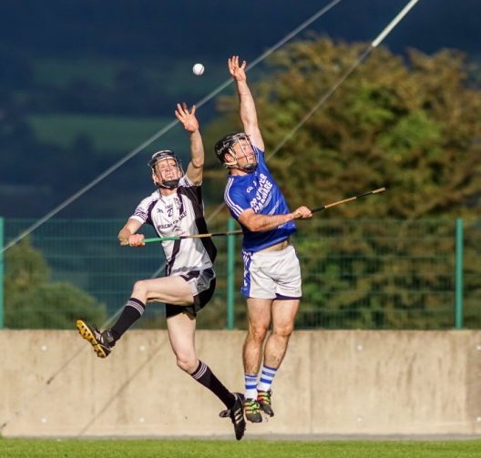
County League
Saturday 9th March in Puckane
Kilruane MacDonaghs 1-14 Kiladangan 1-14

Monday 18th March in MacDonagh Park
Upperchurch 0-20 Kilruane MacDonaghs 0-16

Sunday 28th April in Borrisoleigh
Borris-Ileigh 2-22 Kilruane MacDonaghs 0-15

Saturday 11th May in MacDonagh Park
Kilruane MacDonaghs 1-17 Moycarkey 1-14

Saturday 25th May in MacDonagh Park
Drom & Inch 2-28 Kilruane MacDonaghs 3-13

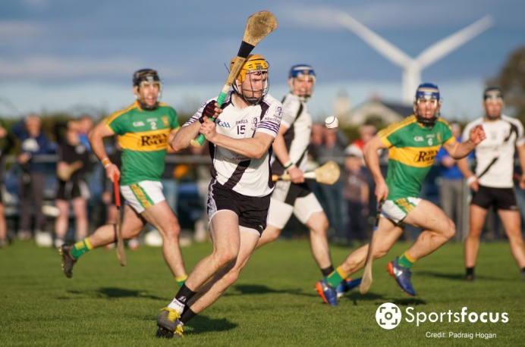
Sunday 9th June in Kilcolman
Burgess 4-17 Kilruane MacDonaghs 1-19

County Championship
Sunday 7th April in Templemore
Kilruane MacDonaghs 2-17 Killenaule 1-18

Sunday 1st September in Templetuohy
Kilruane MacDonaghs 2-24 Thurles 0-18

Saturday 7th September in Templederry
Kilruane MacDonaghs 2-19 Annacarty 2-15

Sunday 13th October in Templetuohy
Kilruane MacDonaghs 1-23 Clonoulty 1-10
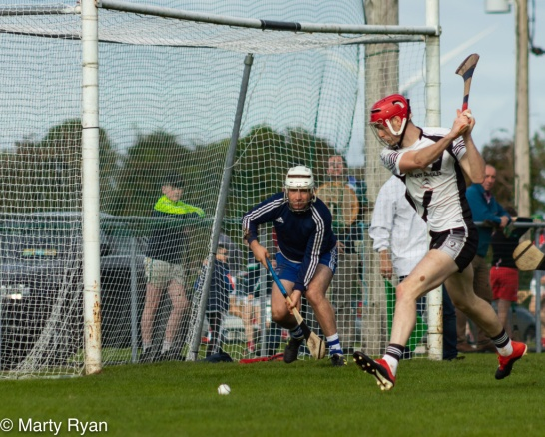
Sunday 20th October in Semple Stadium
Borri-Ileigh 0-16 Kilruane MacDonaghs 0-15

North Championship
Saturday 14th April in Toomevara
Kilruane MacDonaghs 1-21 Silvermines 0-11

Saturday 14th September in Nenagh
Kilruane MacDonaghs 2-16 Kiladangan 1-22

Junior Hurling
At last year’s AGM there was a very good debate on whether we should affiliate in the A or B championship. It was decided we would field in the A championship in 2019 and assess the situation at the end of the season.
As one who argued in favour of remaining in the A championship I have to admit that we were out of our depth. Results speak for themselves. Between League and championship we played nine games and failed to record a victory. We actually conceded our final League game. Our average margin of defeat was 12.5 points. The stark fact is that we haven’t managed a championship victory in three years.
The management team of Martin Walsh, Colin England and David Slattery put in a huge effort and their commitment could not be called into question. However, we simply hadn’t enough bodies in the field. A number of players are living away and could not make midweek training while those on shift work had irregular attendances. Some players were very committed but the lack of commitment by others was reflected in their performances.
In 2020 we are applying to affiliate in the B championship. Our application may or may not be successful. Nobody should be labouring under the misconception that regrading will automatically lead to success. The B championship is a difficult competition to win and unless there is a concerted effort by management and players we can expect further disappointment.

League:
Saturday 23rd March in MacDonagh Park
Kilruane MacDonaghs 4-13 Borris-Ileigh 3-16

Saturday 20th May in Templederry
Kilruane MacDonaghs 2-17 Templederry 1-20

Saturday 27th April in MacDonagh Park
Knockshegowna 1-15 Kilruane MacDonaghs 2-9

Friday 10th May in Newport
Newport 2-22 Kilruane MacDonaghs 1-12

Conceded final game to Toomevara

Championship:
Friday 7th June in Borrisokane
Knockshegowna 0-17 Kilruane MacDonaghs 0-15

Friday 14th June in Kilcolman
Nenagh 3-22 Kilruane MacDonaghs 2-9
Friday 28th June in Toomevara
Borris-Ileigh 3-21 Kilruane MacDonaghs 1-7

Friday 5th July in MacDonagh Park
Burgess 0-18 Kilruane MacDonaghs 0-17

Friday 12th July in Moneygall
Toomevara 2-26 Kilruane MacDonaghs 1-7

Friday 26th July in Toomevara
Roscrea 2-23 Kilruane MacDonaghs 1-13

Minor Hurling

After winning the North ‘B’ championship the club successfully applied to play in this competition in 2019 as we had only four eighteen year-olds on the panel. The Board organised a league but unfortunately we were put into the ‘A’ section and found ourselves out of our depth. We took some heavy beatings which had a negative effect on morale.
We got off to a poor start in the championship against Borrisokane but performed much better in drawing with Silvermines in the second round. A loss to Moneygall/Clonakenny in a high-scoring encounter brought the season to a conclusion.
Some have argued that this team should have trained more often but the reality is that when they did train attendances were not satisfactory. Damian Mulcahy John Quinlan, Eanna Hogan and Niall O’Meara looked after this group while Paddy Williams was also drafted in to do a number of sessions.
All did not run smoothly with this group. Undeniably, there are disciplinary issues with some of the players. In 2020 they will be playing in the A competition. Unquestionably, this team have the ability to be competitive and could challenge for honours. However, it will take gigantic effort from players and management for this team to realise its potential.

Tuesday 16th July in MacDonagh Park
Borrisokane 2-26 Kilruane MacDonaghs 1-13

Wednesday 7th August in Dolla
Kilruane MacDonaghs 1-16 Silvermines 0-19

Wednesday 28th August in MacDonagh Park
Moneygall/Clonakenny 4-26 Kilruane MacDonaghs 8-9

Under 21 Football

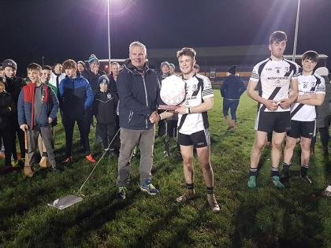
After a narrow defeat in the 2018 final MacDonaghs made no mistake in this year’s decider with an emphatic victory over Ballina. The final received national prominence with the controversy over the eligibility of U17 players. We opted to comply with the Croke Park directive to exclude U17 players while our opponents chose to defy the ruling.
The team gave a polished display of football in the final and put in a tremendous performance against Kilshheelan in the County semi-final. The absence of the injured Jerome Cahill was probably the difference between victory and defeat. Well done to the management team of Tom Killackey, Pat Murphy, Liam O’Kelly and Christy Morgan.

Sunday 10th February in Ballinderry
Kilruane MacDonaghs 3-9 Lorrha/Rovers 2-5

Thursday 28th February in Puckane
Kilruane MacDonaghs 6-13 Ballina 0-9 (North Final)

Wednesday 13th March in Dr. Morris Park
Kilsheelan 3-8 Kilruane MacDonaghs 2-5 (County Semi-Final)

Minor Football

For the second year in succession we played in the ‘A’ championship. We were reasonably competitive but one victory was not enough to earn a place in the knockout stages. In order to protect MacDonagh Park we conceded the home advantage to Kiladangan in the third round. We were due to host Inane Rovers in the second round but this game was postponed due to inclement weather. This game was not refixed as both teams were out of contention for qualification. The minor hurling management team also looked after the footballers.

Sunday 10th March in Nenagh
Kilruane MacDonaghs 3-4 Nenagh 0-6

Sunday 24th March in Ballina
Ballina 2-10 Kilruane MacDonaghs 1-2
Wednesday 27th March in Puckane
Kiladangan 5-9 Kilruane MacDonaghs 4-4

Under 21 Hurling

As has been customary for many years this competition takes place at the end of the season. We received a bye into the semi-final and take on Toomevara in Borrisoleigh on Sunday. We have just missed out on claiming the title in the last few years. Hopefully, we can upset the odds and claim honours this time.

County Representation

Senior: Niall O’Meara, Jerome Cahill, Cian Darcy (All-Ireland & Medallists), Eamon O’Shea (Coach) & Billy O’Shea (Logistics)
Under 20: Craig Morgan (Capt), Jerome Cahill & Kian O’Kelly (All-Ireland & Munster Medallists)
Minor: Páidí Williams

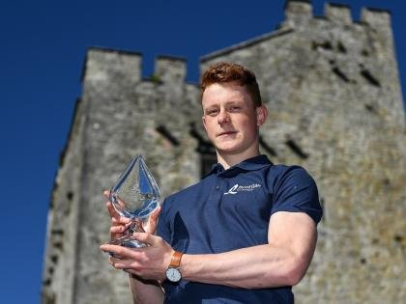
Jerome Cahill
Bord Gáis Energy U20 Hurler of the Year

Tiobraid Árann Abú!
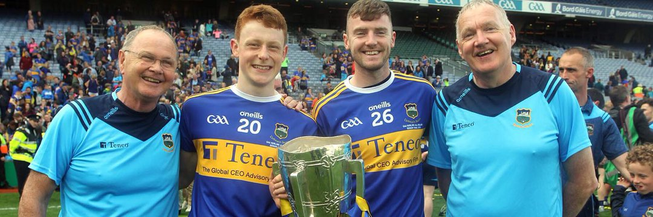

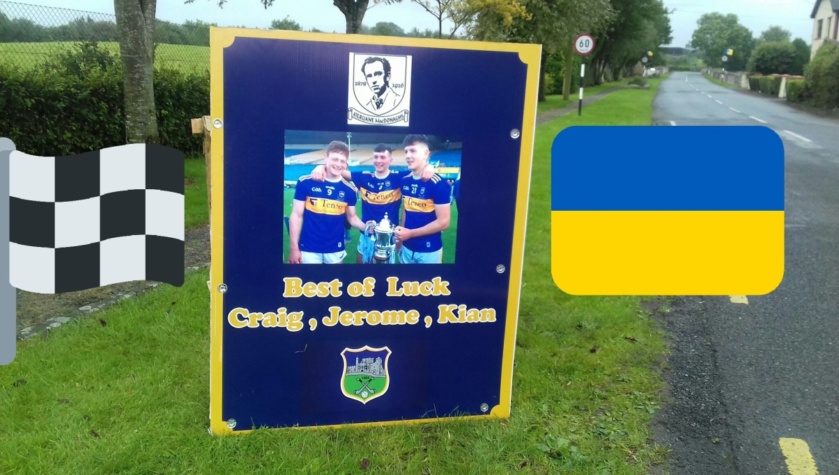

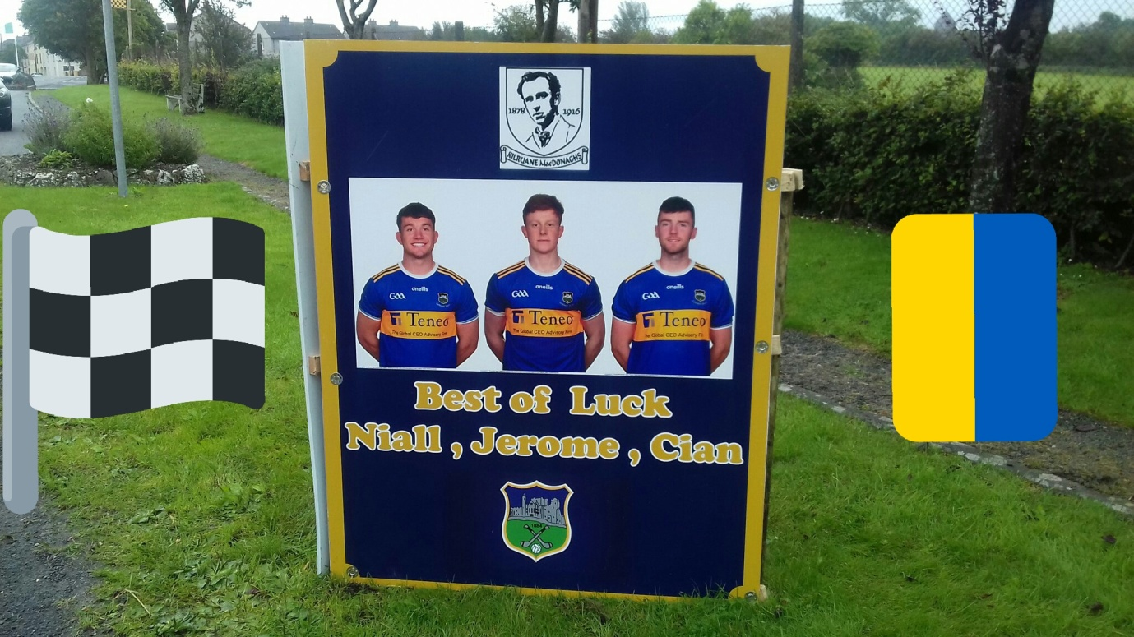

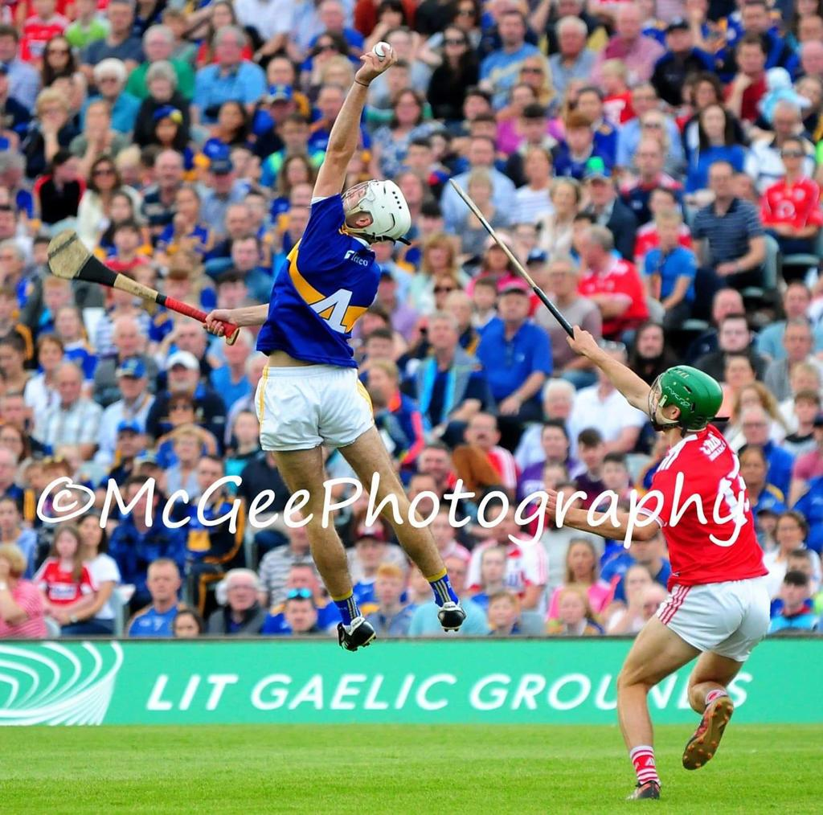
“Plucking it out of the Clouds”

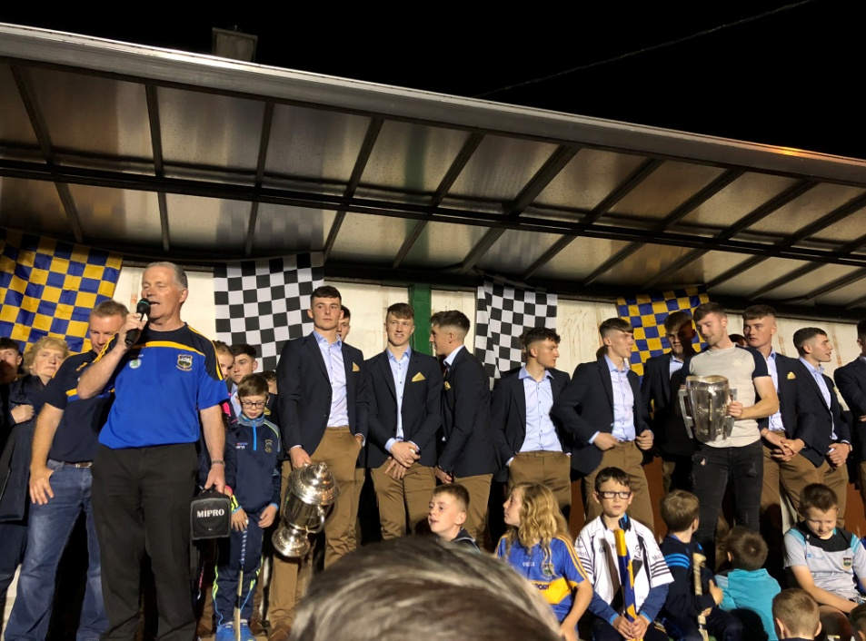

Under 20 Homecoming

Committee
The Committee is the engine room of any club and we are fortunate to have a dedicated group of people working away in the background, shaping policy and carrying out a multitude of tasks on a daily basis. For many years we operated with a very large Committee but it became obvious in recent years that this was too unwieldy with attendances at meetings unsatisfactory.
In 2019 we had a Committee of 17 including two players’ representative. As a result we has a much more cohesive Committee where members felt a greater sense of obligation to attend and contribute to the decision making process.
2019 Committee: Joe Whelan, Mary McLoughney, John Mulcahy, Len Gaynor Carmel Daly, Kay Cahalan, Susan O’Brien, John Jones, Michael O’Meara, John O’Meara, Eoin Kennedy, Matt Cleary (Finance Chairman), Michael Hogan (MacDonagh Park Chairman), Martin Walsh, Jack Peters (Players’ Rep), Conor Doheny (Players’ Rep), Gilbert Williams.
Apart from the members of the Committee there is a large cohort of people in involved in a variety of tasks: Promoting the Lotto; Organising Lotto Draw on Monday nights; Promoting the Tipperary Draw; Selling Draw tickets; Stewarding at MacDonagh Park; Distributing match tickets; and Running the Saturday night Bingo.
.”
“A Lot Doing a Little & Doing it Well”

MacDonagh Park
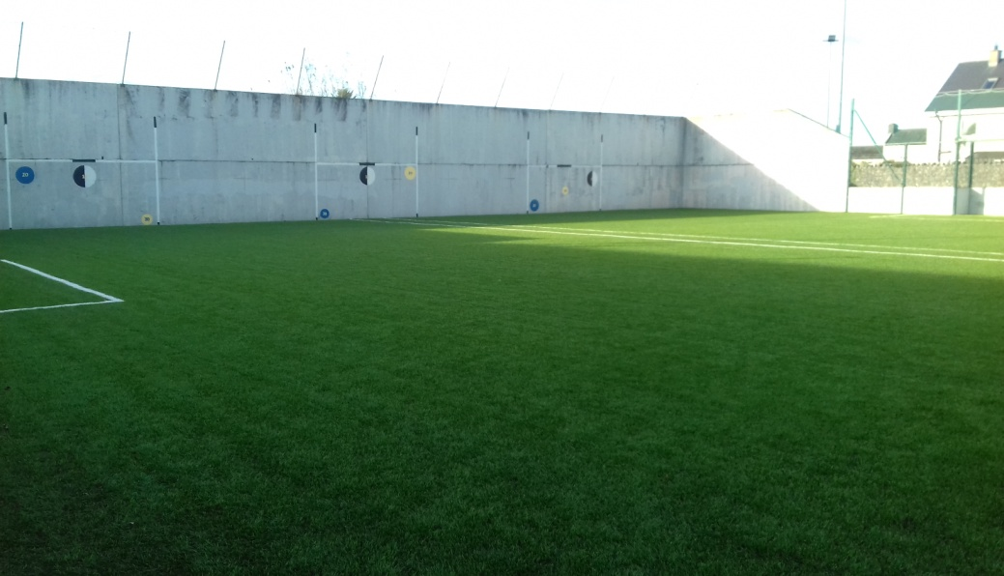
The opening of the Astro Turf provided a very welcome addition to the facilities in MacDonagh Park. Since it opened there have been 177 sessions there. It can be used in bad weather and is of enormous benefit to all our teams. We must make maximum use of this facility to raise the skill level of our players.
Maintaining the pitch and the facilities in pristine condition is a huge task and does not come cost free. The Fás Scheme plays a crucial role in the upkeep of all our facilities. All players and management teams have a duty to protect the pitch in adverse weather conditions and treat club property with respect. While we haven’t a second pitch in Cloughjordan we are fortunate to have an excellent pitch in Ardcroney. It is also maintained to the highest standards and our teams are now using it on a more regular basis.
Tom Cleary
1926-2019
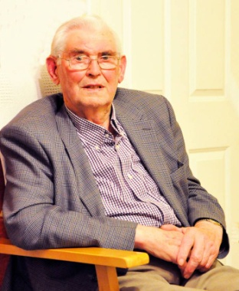
The late Tom Cleary, Kilruane MacDonaghs President, was an iconic figure in our parish and our club. He gave distinguished service to Kilruane MacDonaghs and various farming organisations. In 1948 he was one of the founding members of the Cloughjordan Young Farmers Club, an organisation that later changed its name to Macra na Feirme. Tom was chairman of Tipperary Macra from 1956 to 1967.
In 1960 Tom was elected to the National Council of the NFA and the National Dairy Committee and held that position until 1970. The same year he became treasurer of the IFA. Tom looked after the finances for four years and in 1974 he was elected a member of Bord Bainne, now known as the Irish Dairy Board. He became chairman in 1982 and held that position until his retirement in 2000. Tom is the only member to have served continuously for a period of twenty-eight years. He was also a long-time member of the Nenagh Show Committee, serving as chairman in 1971 and 1972.
Tom’s contribution to Irish farming did not go unrecognised. In 2003 he received the Horace Plunkett Award from the Irish Co-operative Organisation Society for his contribution to the Irish Co-operative movement; the Paddy Fitzgerald Award recognised his outstanding voluntary contribution to the welfare of Munster farmers and their communities while the IFA made him an Honorary lifetime member.
In 1949 Tom played corner-back on the Cloughjordan team that lost the North junior final to Knockmeal Rangers. The following year he captained the Kilruane MacDonaghs junior team to win the North Tipperary championship by overcoming Burgess in the final. The same year Tom led the juniors to victory over Shannon Harbour of Offaly in the Lord Abbot Cup final that was played in St. Brendan’s Park, Birr. Tom continued to play intermediate hurling with Kilruane MacDonaghs until 1953. His farming commitments were now becoming more demanding so his playing career came to an end.
Tom still continued to follow the fortunes of Kilruane MacDonaghs and Tipperary. He was a member of the club committee for over forty years. In 1984 he became vice-chairman and was appointed chairman in 1989. During his five-year term in the chair he saw Kilruane MacDonaghs win the North senior hurling title in 1990, something that gave him immense satisfaction. Tom was elected Vice-President in 1997 and succeeded Canon Whyte as President in 2001. He has held that honorary position since then and in doing so he became the longest-serving President in the history of the Kilruane MacDonaghs club. In 2010 the Tipperary County Board recognised his service to the GAA when he received a Sean-Ghael Award.
At his funeral his coffin was draped in the club colours. Three generations of Kilruane MacDonaghs members formed a Guard of honour and walked in silent tribute as Tom made his final journey to Cloughjordan Church. As a mark of respect the scheduled minor football game against Kiladangan was postponed and a minute’s silence was observed before the senior league game against Kiladangan. Tom was also remembered in the minute’s silence before the Tipperary and Cork encounter.
Sympathy is extended to his son Dermot, daughter Deirdre, son-in-law Roger, grandchildren Roisín, Kevin and Jack, sisters, Kitty, Sr Peggy and extended family. Go soilsí solas na bhFlaitheas ar a anam uasal.

Michael Cahill
1952-2019

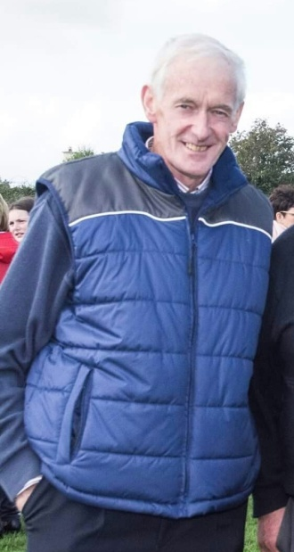
On Sunday, 5th May we laid to rest Michael Cahill, one of the greatest stalwarts in the history of Kilruane MacDonaghs club. He first played juvenile hurling with MacDonaghs in 1966. He won the following North & County medals: U21 1973; Intermediate 1978; Senior 1979; and Junior 1985. In addition he collected divisional medals in Junior (1975) and Intermediate League (1987). Michael wore the number one jersey during his adult playing career. He was also a shrewd judge of a player and served as a senior, junior and U21 selector.
Michael was a member of the club committee since 1971 and he gave forty-eight years unbroken service in a variety of roles. In 1973 Michael was elected assistant secretary and spent six years as an understudy to Tom Kirby. In 1990 he was appointed County Board Delegate and for ten years he was an able club representative in that position. In 1996 Michael was installed as assistant treasurer before being promoted to treasurer in 1998. He was in charge of club finances for the next thirteen years, stepping down from minding the purse strings at the 2011 AGM. However, Michael was given very little respite as in 2013 he took up the position of assistant treasurer for the second time. At last year’s AGM he was unanimously reappointed for the seventh successive year.
In one shape or form Michael was deeply immersed in the monetary affairs of the club since 1988 when he was a member of the Finance Committee. And it is no mere coincidence that he has been such an influential figure in this area as Michael was the personification of honesty and integrity. He was a master fundraiser with few peers. Michael was a Tipperary Draw promoter since its inception in 1988. He was one of the driving forces behind the Club Lotto which commenced in 1996 and his home was the unofficial headquarters of the Lotto Committee up to recently. In our hugely successful Sales of Work Michael was always in the thick of the action.
Outside the Kilruane MacDonaghs club Michael is best known in GAA circles as a referee. He started his career with the whistle in 1974. His first final was the 1975 North U14 Urban/Rural decider and he went on to referee finals in all grades in both hurling and football. Michael’s first North senior hurling final was in 1988. He refereed six more senior finals. One of the highlights of his career was in 1997 when he officiated at the County senior final that saw Clonoulty defeat Mullinahone. Michael refereed at inter-county level and was fourth official on a number of occasions. At this year’s North Board Awards night in the Kilruane MacDonaghs clubroom he was honoured for his 45 years of distinguished service as a referee. Michael had the composure, courage and above all common sense that made him a top-class referee. He knew all the rules of hurling but more importantly he knew the game and had the ability to let the game flow without losing control.
The name of Michael Cahill will always be associated with MacDonagh Park. He took great pride in this magnificent venue and led by example in maintaining the facilities in pristine condition. Michael was to the fore in all the major development works: the erection of the stand in 1995; the construction of the Complex which was officially opened in 2006; and building the Hurling Wall in 2009. Michael was an enthusiastic supporter of the Astro Turf project which came on stream in February.
Michael was much more than a great GAA man. He had a long involvement in the Credit Union, gave twenty-three year’s service in the local Fire Brigade and was supervisor of the Fás scheme until his retirement last year. Above all he was a great friend and neighbour to many in the community.
It was fitting that he reposed in the Kilruane MacDonaghs clubroom at MacDonagh Park. The thousands that attended his funeral over the two days showed the esteem in which he was held by people all over the country. His coffin was draped in the MacDonaghs colours and on his final journey to Cloughjordan Church a massive community Guard of Honour walked in silent tribute.
Sympathy is extended to his daughters Niamh and Louise, their mother Delia, granddaughter Caragh, his mother Peg, his partner Chris, son-in-law Donal, brothers, sisters, brothers-in- law, sisters-in-law, uncle, aunts, nephews, nieces, relatives and many friends especially James.
Leaba i measc na naomh dó.

John Lawlor
1933-2019
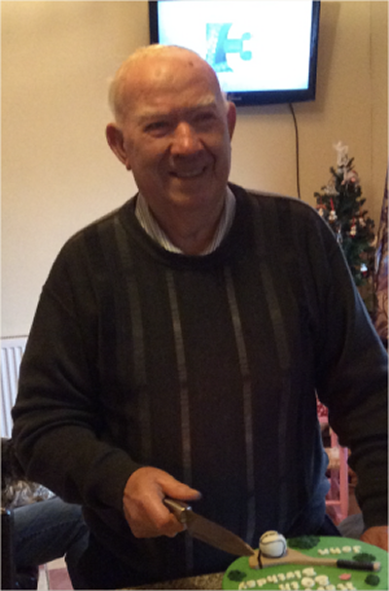
On Tuesday, 18th June John Lawlor passed to his eternal reward. The late John was a great servant of both Nenagh Éire Óg and Kilruane MacDonaghs. He played hurling and football with his native Nenagh but found his true niche as an administrator and selector. John served as chairman, secretary and treasurer with Nenagh. He was in the chair when they captured the North senior title in 1964. John was a selector with a variety of teams including the senior side and he did Trojan work with the juveniles in the town.
Having settled in Lisgarode, he was appointed to the Kilruane MacDonaghs committee in the mid eighties. John became a very active and effective member of the club executive. He acted as secretary between 1993 and 2000. John was North Board delegate (1993-2005). This was a role he has previously filled with Nenagh. John was highly respected by fellow delegates and his conciliatory style enabled him to achieve results in the boardroom.
His talent as an administrator saw him fill the role of North Bord na Óg secretary (1964-1967). John also acted as vice-chairman for a period. For six successive years (1970-1975) he was elected as one of the four North Tipperary representatives on the County Board. John also filled the role of North Board Registrar (1976-1978).
He was a shrewd judge of a hurler and with MacDonaghs he served as a selector with the intermediates (1988/’89), juniors (1990/’91) and the minors (1989). John used all his powers of persuasion to entice reluctant junior players to line out with teams that often had very little hope of success. For many years John was a very loyal and dependable volunteer at the Saturday night bingo sessions in the Fr. Niall O’Meara Centre. In 2014 the Tipperary County Board recognised his service to Nenagh Éire Óg, Kilruane MacDonaghs and the North Board when he was the recipient of a Sean Ghael Award.
To his wife Mary, daughter Colette, sons Damian, Sean and David & extended family sympathy is extended. Suaimhneas síoraí dó.

Ned Gaynor
1930-2019
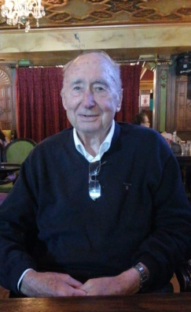
On Friday, 11th October Ned Gaynor passed away peacefully at University Hospital, Limerick. Ned was born in Melbourne on the 9th July 1930. His father Mick had been deeply involved in the War of independence and emigrated to Australia in 1924. Mick married an Australian/Irish girl Eileen Murphy. The Gaynor family returned to Ireland in 1939 and settled in Rapla, Kilruane where Mick had taken over his uncle’s farm.
Ned attended the local national school in Kilruane and headed to Nenagh C.B.S. to complete his secondary education. A classmate of his was Fr. Alex Reid who was later to play a prominent role in the Northern Ireland Peace Process. In 1944 Ned played on the MacDonaghs juvenile team (U15) that defeated Templederry in the North final and went on to get the better of Holycross in the County final that was played as a curtain raiser before the senior final between Thurles and Kilruane in Borrisoleigh.
Ned did his apprenticeship with the ESB in Limerick. He was involved in the Rural Electrification Scheme which helped transform the lives of people living outside the urban centres. Travelling back for training and matches wasn’t practical in those days so his hurling career petered out although he did play a few matches with the local St. Ruadhan’s junior team.
In 1955 he married Kaye O’Sullivan from Blackrock in Cork. Ned lived in Cahir, Nenagh and Newcastlewest before finally settling with his family in Ennis in 1967. Ned always followed the fortunes of both Kilruane MacDonaghs and Tipperary. Ned and his wife Kaye travelled extensively. He enjoyed a game of cards, was a keen golfer and a member of the Ennis Lions Club.
To his daughters Brenda, Ursula and Maelisa, his sisters Mary, Julia, Maelisa and Imelda, his brothers Des and Len and extended family sympathy is extended. Ar dheis Dé go raibh a anam uasal.

Mikey McDonald
1964-2018
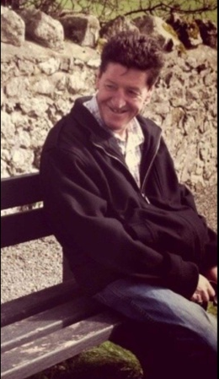
On the 19th December 2018 Cloughjordan village was saddened by the sudden death of Mikey McDonald. The late Mikey was born in Camden, New Jersey in 1964, the fourth eldest child of Mary Bowe and Hughie McDonald. The same year his family returned to Ireland and settled in Main Street, Cloughjordan. Hughie McDonald was a native of Cornafean, Cavan. Cornafean was the home club of legendary Cavan footballer John Joe Reilly. Hughie brought his love of football to Tipperary and in 1975 he teamed up with another Cavan native Frank Brady and Paddy Quinlan in guiding the Kilruane MacDonaghs senior football team to win the County title.
Mikey played his first game with the MacDonaghs U12s in 1974. Two years later he was goalkeeper on the U14 team, captained by Michael Conway, that overcame Toomevara in the North Rural final.
In 1978 Mikey collected his second divisional U14 medal when he lined out at corner-forward on the team that got the better of Borris-Ileigh in the North final. That side, captained by Jack Darcy, went on the claim the County title and the Harty Shield with a victory over Ballingarry in Semple Stadium. Mikey raised a green flag in both finals.
In 1980 he filled the corner-forward spot once more when MacDonaghs, captained by Tommy Byrne, saw off the challenge of Toomevara in the North U16 decider that was played in Roscrea. Mikey reverted to wearing the goalkeeper’s jersey at minor level but his career petered out after that and he moved to Streatham, South London in the mid eighties.
In 1998 Mikey returned to Cloughjordan and made his home in Church Road. He was one of the most likeable, roguish and colourful characters in the village and Cloughjordan will be a duller place without his presence.
On Mikey’s final journey to Cloughjordan Church club members formed a guard of honour. To his daughters Melissa and Sinéad, son Daniel, mother Mary, sisters Sheila and Moira, brothers Tommy, Joe and Seamus and extended family sympathy is extended. Solas Mhic Dé ar a anam.

Sympathy to all who suffered bereavement during 2019

2019
- Niall O’Meara, Jerome Cahill & Cian Darcy All-Ireland senior medallists
- Craig Morgan (Capt), Jerome Cahill & Kian O’Kelly Munster and All-Ireland U20 medallists
- Jerome Cahill Bord Gáis Energy U20 Hurler of the Year
- North U21 ‘B’ Football Champions
- North U12 ‘C’ Hurling Champions (Second Team)
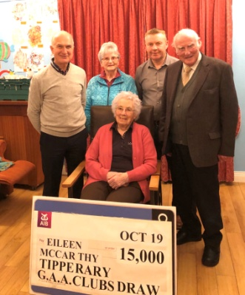
- Cloughjordan Schools North U13 Hurling Champions
- Ardcroney N.S. North U13 Hurling Champions
- Ardcroney N.S. County U11 Hurling Champions
- Kilruane N.S. County U11 Hurling Finalists
- Official Opening of Astro Turf
- Martin O’Meara Laochra Gael
- Eileen McCarthy, Ballycapple Winner of €15,000 in Tipperary Draw
- Limited Draw 1,120 Tickets Sold
Never give up, for that is just the place and the time that the tide will turn.

